**Electrophysiology Measurement and Stimulation**

Electrical and Computer Engineering 4820

August 30, 2010

|  |  |  |  |  |
| --- | --- | --- | --- | --- |
| Authors: | Kyle Batzer  Richard Corsi  Edward Crampton | |  | |
|  |  | |
|  |  | |  | |
| Advisors: | Dr. Damon Miller  Dr. Frank Severance | | Dr. Bradley Bazuin  Dr. John Gesink | |
|  |
|  |
|  | | |  | |

**ABSTRACT**

The WMU Neurobiology Engineering Laboratory plans to investigate temporal and spatial signal processing by neuronal cells cultured on Microelectrode Arrays (MEAs). A relatively low-cost prototype for measurement and stimulation of electrical activity in neuronal cell cultures via 60 electrodes provided by a MEA has been developed and tested to support that research. The four channel prototype features low-noise amplification and PC data acquisition of electrode voltages and support for automated closed loop or user defined voltage stimulation signals. The design builds on previous work by WMU faculty and students as based on the research literature.

MILLER TO INSERT DISCLAIMER HERE

MILLER TO INSERT RELEASE FORM HERE

**ACKNOWLEDGEMENTS**

Special thanks to all of those involved in the completion of this project:

* Drs. Bradley Bazuin, John Gesink, Damon Miller, and Frank Severance along with Ph.D. students Mike Ellinger and John Stahl for their guidance throughout the project.
* Michigan Space Grant Consortium: (undergraduate research fellowship for Kyle Batzer).
* Seibert WMU Undergraduate Research and Creative Activities Award Program
* Sunstone Circuits

Table of Contents

1. Description 8

2. Need 9

3. Specifications 10

3.1 Analog Subsystem 10

3.2 Digital Subsystem 11

3.3 Operational 11

4. System Design 12

4.1 Low-Noise Amplification and Filtering 12

4.1.1 First Stage of Amplification and Filtering 13

4.1.2 Second Stage of Amplification and Filtering 15

4.2 Data Acquisition 20

4.3 Stimulation 23

4.4 Physical Implementation 26

4.4.1 Printed Circuit Board 27

4.4.2 Enclosure 29

5. System Validation 31

5.1 Low-Noise Amplification and Filtering 32

5.1.1 Frequency Response (Pre-Amplifier and Amplifier) 33

5.1.2 DC Settling Time (Pre-Amplifier in Measurement Mode) 36

5.1.3 Basic Functionality 37

5.1.4 Operational Functionality 38

5.1.5 Noise/Offset (Pre-Amplifier and Amplifier) 39

5.2 Data Acquisition 40

5.2.1 Data Acquisition 40

5.3 Stimulation 41

5.3.1 User-Defined Stimulation 41

5.4 Full System Integration 42

5.4.1 Recording of User-Defined Stimulation 42

6. Conclusions 43

7. Recommendations 43

8. Budget 44

9. References 44

10. Project Materials 46

11. Appendices 46

11.1 Freescale Semiconductor CodeWarrior Software User Guide 47

11.2 Xilinx ISE Design Suite for a Digilent Nexys2 FPGA Board User Guide 49

11.3 Microsoft Visual Studio® User Guide 54

11.4 Parts List 57

# 1. Description[1]

Building on previous work at WMU [, , , ], existing commercial systems [www.multichannelsystems.com], and research literature [e.g. ] a system for research into the computational properties of biological neural networks has been developed. The developed prototype supports research using cells cultured on a Microelectrode Array (MEA) that typically provides 60 electrodes [www.multichannelsystems.com] for measuring and stimulating the electrical activity of the cell culture at different locations []. MEA electrode voltages must be amplified, sampled, and digitized for storage and analysis. A stimulation voltage can be applied to any of the 60 electrodes based on either a user defined signal or automated feedback [6] that utilizes acquired samples of culture voltages. Use of a MEA provides a means of viewing the electrical activity of a neuron culture over an extended period of time, allowing insight into how the network changes over time, given various stimuli [7].

A single neuron connects with many other neurons to form a neural network. The dendrites of a neuron can be viewed as the “inputs” of the neuron and the axon can be viewed as the “output” of the neuron. The axon branches out at the end to connect to the dendrites of other neurons. This connection between axon and dendrite is the synapse. Communication between connected neurons is characterized by electrical pulses called action potentials. When a cell membrane reaches its threshold voltage, ion channels open causing an inflow of sodium ions, followed by an outflow of potassium ions. This causes a chain reaction and the action potential is propagated down the axon [].

Not every synaptic connection is equivalent. Varying amounts and types of chemical messengers, known as neurotransmitters, are released. Some neurotransmitters are considered excitatory and some are considered inhibitory. Thus a synapse can tend to either facilitate or suppress generation of an action potential. This means even though a neuron fires an action potential, a connected neuron will not necessarily be influenced to do the same. If the sum of all neuron inputs raises the membrane potential past a threshold voltage, an action potential will be generated [].

In order to effectively study biological neural networks, one must be able to spatially and temporally analyze culture interactions. This involves being able to determine the effect of stimulus at one point of the network on another point in the network. A MEA allows the study of these effects. Electrodes are evenly spaced across the culture dish, creating a grid for measurement and stimulus. Learning in neural networks can be studied by viewing the changes in how strongly cells surrounding a particular electrode are influenced by stimulation of another, spatially separate, region of the cell culture via an electrode [].

# 2. Need

A similar system has been developed by Multi Channel Systems (www.multichannelsystems.com); however, the price for such a system is approximately $50,000, an amount that significantly exceeds current lab resources. The developed system provides a low cost, flexible solution for long term MEA-based research. In its current state, four channels are available for measurement, stimulation, and recording. The developed four channel system creates a foundation on which a 60 channel system could be realized.

The flexibility and relatively low cost of this system is what makes it unique. Anyone from a student to a major pharmaceutical company could make use of the system. This system is a first step to realize a larger system intended for research into the computational properties of biological neural networks being performed at the Western Michigan University (WMU) Neurobiology Engineering Laboratory. A cell culture protocol has been developed [] and previous work on such a system [, ] including low noise amplification has been completed []. Initial analytical algorithms have also been developed []. With this four channel system now complete, data will be captured from biological neural networks to support research of the computational properties of neural networks. Consult [, 2, , ] for additional references in this research area.

Once the system has been proven through research at the WMU Neurobiology Engineering Laboratory, other potential users of the system could be identified. As discussed above, there are many potential customers for this type of system that are currently unable to afford the larger scale, commercially available systems.

# 3. Specifications

The following specifications describe an expandable four channel system to meet the described need. These specifications are largely based on previous work [1,2] as based on commercial Multi Channel Systems systems and the research literature.

## Analog Subsystem

1. The system must have low noise characteristics including a low noise figure [].
2. The system must provide 1000V/V passband electrode voltage gain.
3. The system must have a maximally flat passband between 20Hz and 20kHz.
4. The system must use an instrumentation amplifier (IA) based circuit as described in [1, 2, ] as largely based on [].
5. The instrumentation amplifier must not saturate during stimulation.
6. The system must have test points to access critical signals.

## Digital Subsystem

1. The stimulation system must be able to generate user-defined stimulation signals at each of the four electrodes.
2. The stimulation system must support stimulation from an external source.
3. The system must have a sampling rate of 48 kSamples/channel.
4. The system must provide 16-bits of resolution for sampled electrode voltages.
5. The system must be able to record time stamped or aligned measurement and stimulation data continuously for 30 minutes.
6. The system must process sampled electrode signals in real-time to compute and generate stimulation signals based on a five minute history of electrode signals. This time history must be readily expandable.

## Operational

1. The system must have a selectable measurement/stimulation mode for each channel.
2. Each channel must default to measurement mode.
3. The system must support four channels and be expandable to 60 channels.
4. The system must have a self-test loop that verifies all subsystems are functioning properly.
5. The system must have a power indicator.
6. The system must maximize hardware and software flexibility.
7. The system must interface with a Multi Channel Systems MEA interface fixture (Model: MEA 1060 housing (without electronics)).

# 4. System Design

As stated before, the developed system is an important piece of a larger research effort, and is based on previous work at WMU [, , , ], existing commercial systems [www.multichannelsystems.com], and research literature [e.g. 5, 6]. The larger project is made up of five major components: cell culture on a MEA, low-noise amplification, data acquisition, stimulation, and PC. Figure shows how these areas interact and gives a broad overview of the entire project.

|  |
| --- |
| C:\Users\Kyle\Desktop\School\Senior Design\Presentation\Project Overview.gif |
| Figure 1: Project Overview (MEA 1060 housing from Multi Channel Systems shown) |

This project addressed low-noise amplification, data acquisition, and stimulation, with some work on the PC end for storage of measured electrode and stimulation signals.

## 4.1 Low-Noise Amplification and Filtering

The low-noise amplification and filtering system is comprised of two amplification and filtering stages. The first stage is placed close to the MEA to minimize noise as in the commercial Multi Channel Systems product. The second stage of amplification is implemented on the same printed circuit board (PCB) as the first stage but contains perforations to allow the placement of the second stage of amplification to be moved farther away from the MEA if desired. The different sections of the PCB can be seen in Figure 13. These two stages combine for an overall gain of 1000 V/V, sufficient to provide amplified electrical signals in the desired range for data analysis. The first and second stages also contain filters with a passband of 20Hz to 20kHz, to remove any DC signal component and to prevent aliasing [].

### 4.1.1 First Stage of Amplification and Filtering

The first stage of amplification and filtering consists of a summing circuit, integrating circuit and an AC coupled instrumentation amplifier. The summing circuit is used in order to add a reference voltage (DC offset) to the input stimulation signal. This preserves the DC level during stimulation []. The integrator circuit sets the initial 20 Hz corner frequency of the system and stores a scaled DC offset voltage. The AC coupled instrumentation amplifier provides an initial gain of 50V/V. The first stage of amplification and filtering schematic is shown in Figure and is based on previous research work [3, 5] and the LT1167 datasheet [10].

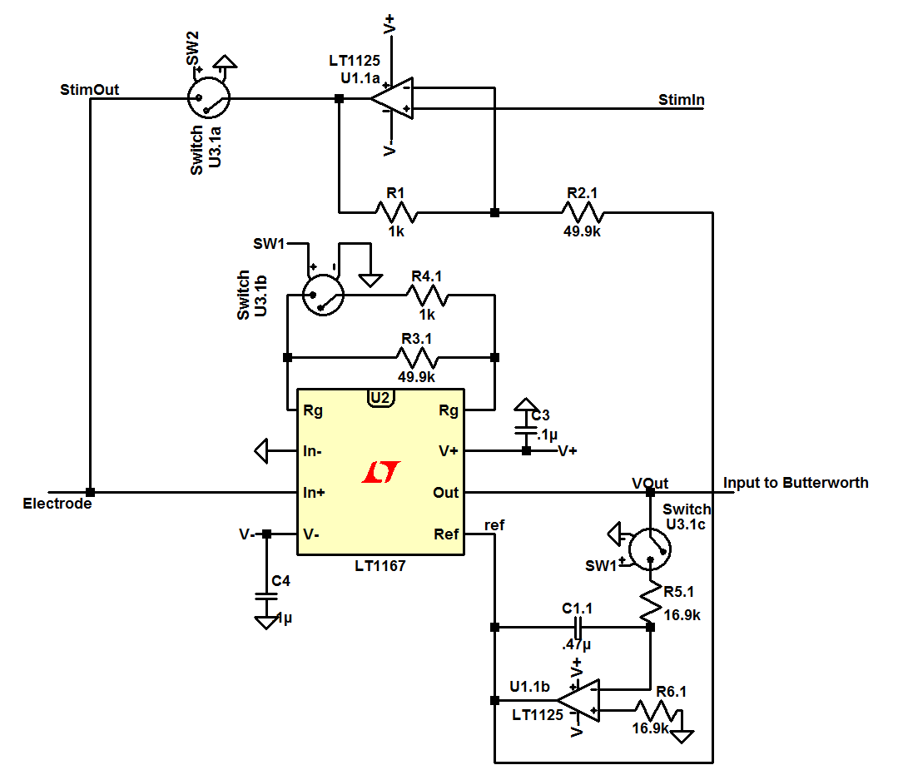

Figure 2: First Stage of Amplification and Filtering based on [3, 5] and LT1167 datasheet [10]

The only changes as compared to [3] made to the first stage of amplification and filtering were the values of R2, R4, and R6. These values were changed in order to adjust theoretical values to common industry resistor values for 1% tolerance resistors. R5 was not changed since it controls the corner frequency of the integrator

$f_{c}=\frac{1}{2πRC}$.

Thus a capacitor of .47μF and a resistor of 16.9kΩ yield a corner frequency of 20.037Hz. The operational amplifiers selected for the integrator, summing circuit, and Butterworth filter (as described on the next page) are the LT1124/25 [].

The AC coupled instrumentation amplifier is shown as the LT1167 for stimulation purposes. An equivalent INA111BU-ND was used in its place []. In order to obtain the required gain of 50V/V a 49.9kΩ and 1kΩ resistor are used in parallel. The voltage gain of the circuit is given as [12]

$G=1+\frac{50k}{R_{g}}$.

Thus with an RG of a 1kΩ and 49.9kΩ in parallel, the resulting gain is 52V/V when switch U3.1b is closed. Resistor R4.1 can be selected to avoid saturation of the instrumentation amplifier during measurement mode.

The switching order of the three switches was designed in order to completely separate the stimulation and measurement modes as inspired by [5]. When the device is in stimulation mode SW2, from the schematic above, is closed with the other two switches open. The opposite is true when the device is in measurement mode. This prevents saturation of the IA and preserves the DC level of the electrode.

### 4.1.2 Second Stage of Amplification and Filtering

The output from the first stage of amplification and filtering then enters the second stage of amplification and filtering. The second stage consists of two filters; a Butterworth filter [13] and high pass filter [3]. The output of the instrumentation amplifier enters directly into a 6th order low pass Butterworth filter (Figure ). The circuit was modified from its original design [] in order to use industry standard values for the resistors and capacitors and to provide a 3dB frequency of 24kHz [13]. The gain for each stage is noted in Figure along with the total gain of 4.26 V/V for the entire Butterworth filter.

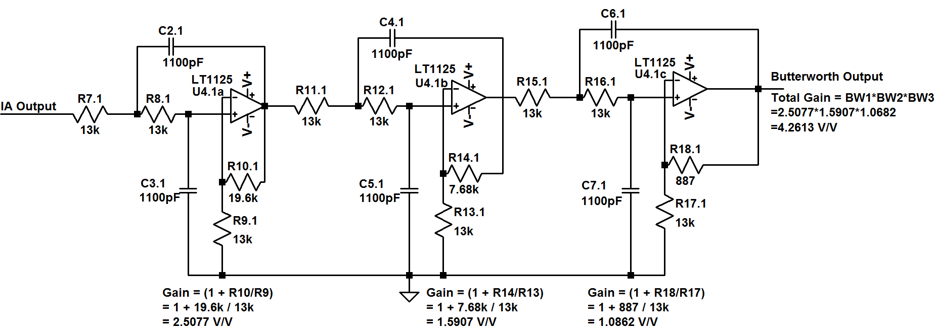

Figure 3: 6th Order Low Pass Butterworth Filter (Adapted from [3])

The output of the Butterworth filter is connected to the input of a 2nd order high pass filter [] shown in Figure . Detailed high pass filter calculations are now provided. The transfer function of the circuit can be found by applying a node equation at the negative terminal of the operational amplifier. The node equation is

$$\frac{V_{in}-0}{R_{19}+\frac{1}{sC}}=-\frac{V_{out}}{R_{20}}$$

and the gain is given as

$\frac{V_{out}}{V_{in}}= -\frac{R_{20 }}{R_{19}+\frac{1}{sC}}$.

Multiplying by s/s yields

$T\left(s\right)=-\frac{R_{20}s}{R_{19}s+\frac{1}{C}}= -\frac{R_{20}}{R_{19}}*\frac{s}{s+\frac{1}{R_{19}C} }$.

The desired corner frequency as determined by the resistor and capacitor of the integrator circuit earlier is to be 20.037Hz. The desired component values needed to achieve this corner frequency are the same as in the integrator circuit. Therefore, a resistor of 16.9kΩ and a capacitor of .47 µF are used. The gain of the circuit is given by R20/R19. The resulting gain is 4.657V/V. The complete schematic can be seen in Figure 4. The high pass filter removes any DC offset that has accumulated in the circuit and results in an overall system gain of 991.94V/V as seen in the block diagram below seen in Figure **Error! Reference source not found.**. The entire schematic is provided in Figure .

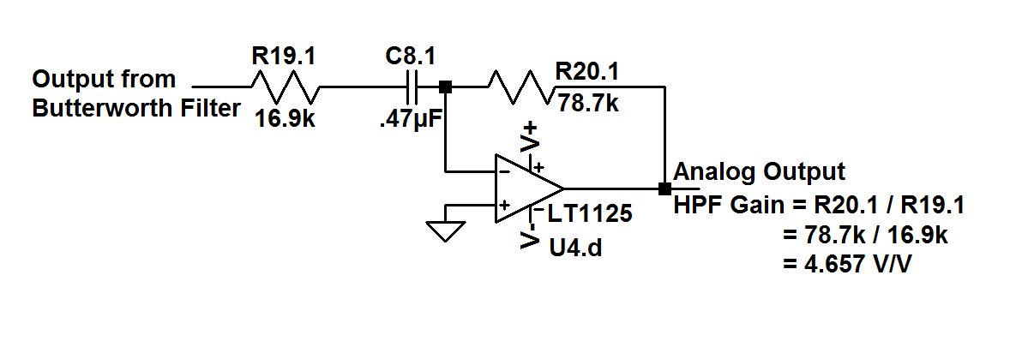

Figure 4: High Pass Filter Design (Adapted from [])

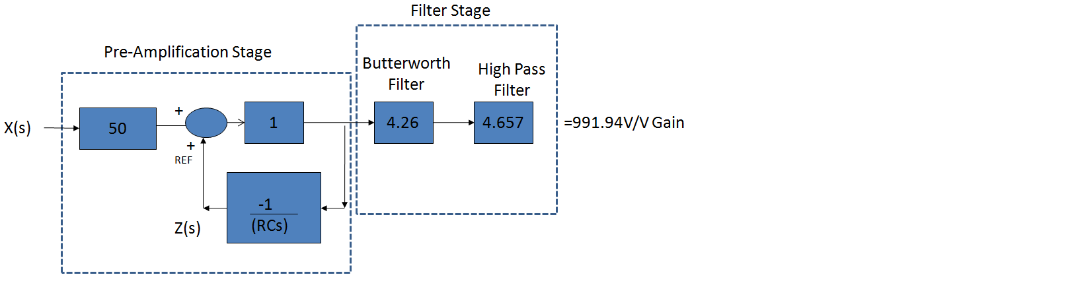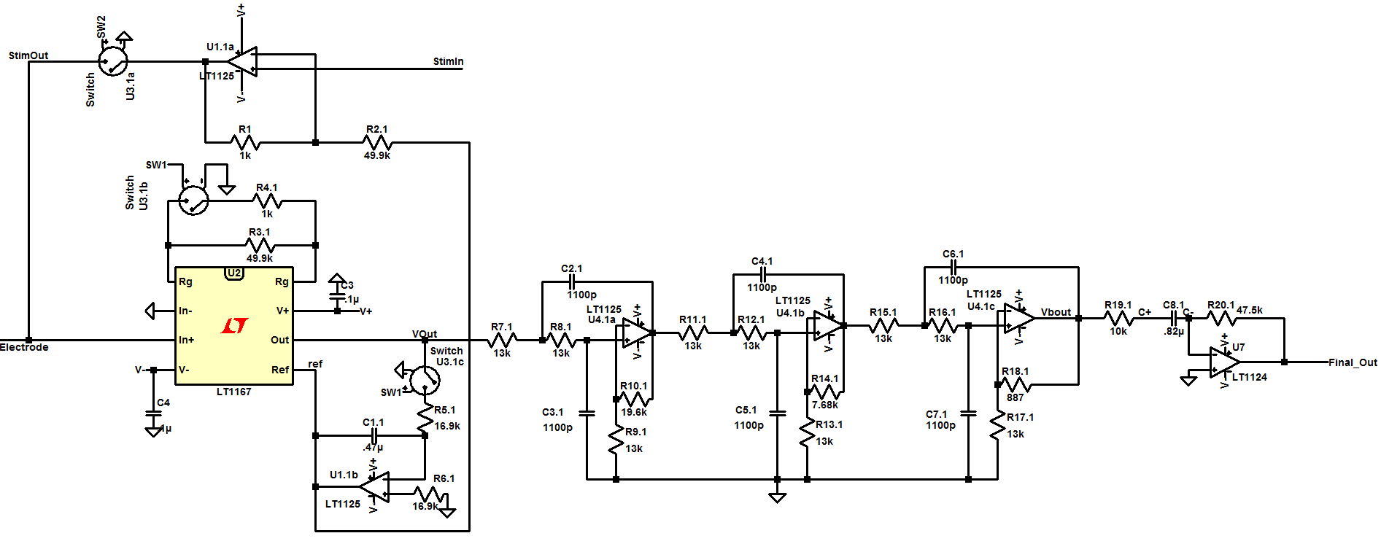

Figure : Block Diagram of Pre-Amp and Analog Amplifier Filter

Figure 6: First and Second Stage Amplification and Filtering

## 4.2 Data Acquisition

After an electrode voltage signal is amplified and filtered, it must be sampled, digitized, and forwarded to the computer. Figure provides an overview of the data acquisition system and Figure 8 provides a detailed schematic showing the interconnections between each component within the data acquisition system.

|  |
| --- |
| C:\Users\Kyle\Desktop\School\Senior Design\Presentation\Data Acquisition.gif |
| Figure 7: Data Acquisition System |

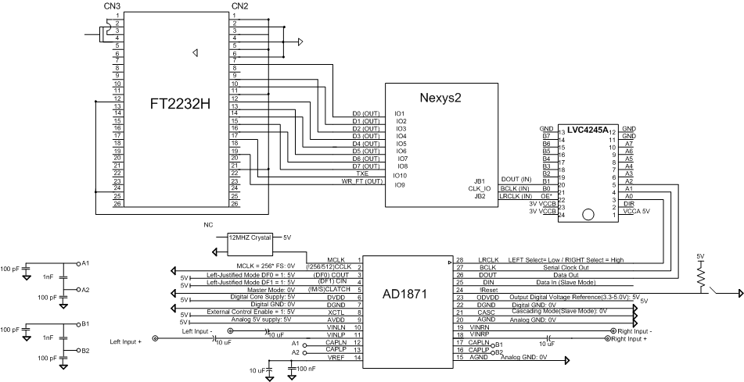

Figure 8: Data Acquisition Schematic

The initial stage of the data acquisition system is an Analog-to-Digital Converter (ADC). The ADC used is Analog Devices AD1871. It is an audio ADC meaning voltage signals from two electrodes can be sampled by a single AD1871. The developed project currently uses the AD1871 to sample data at 48 kSamples/Channel with 16-bit resolution. The AD1871 allows operational settings to be defined by either pulling certain pins high or low as shown in Figure 8 (refer to [14] for more details). Digitized data passed in serial from the AD1871 as shown in Figure 9.

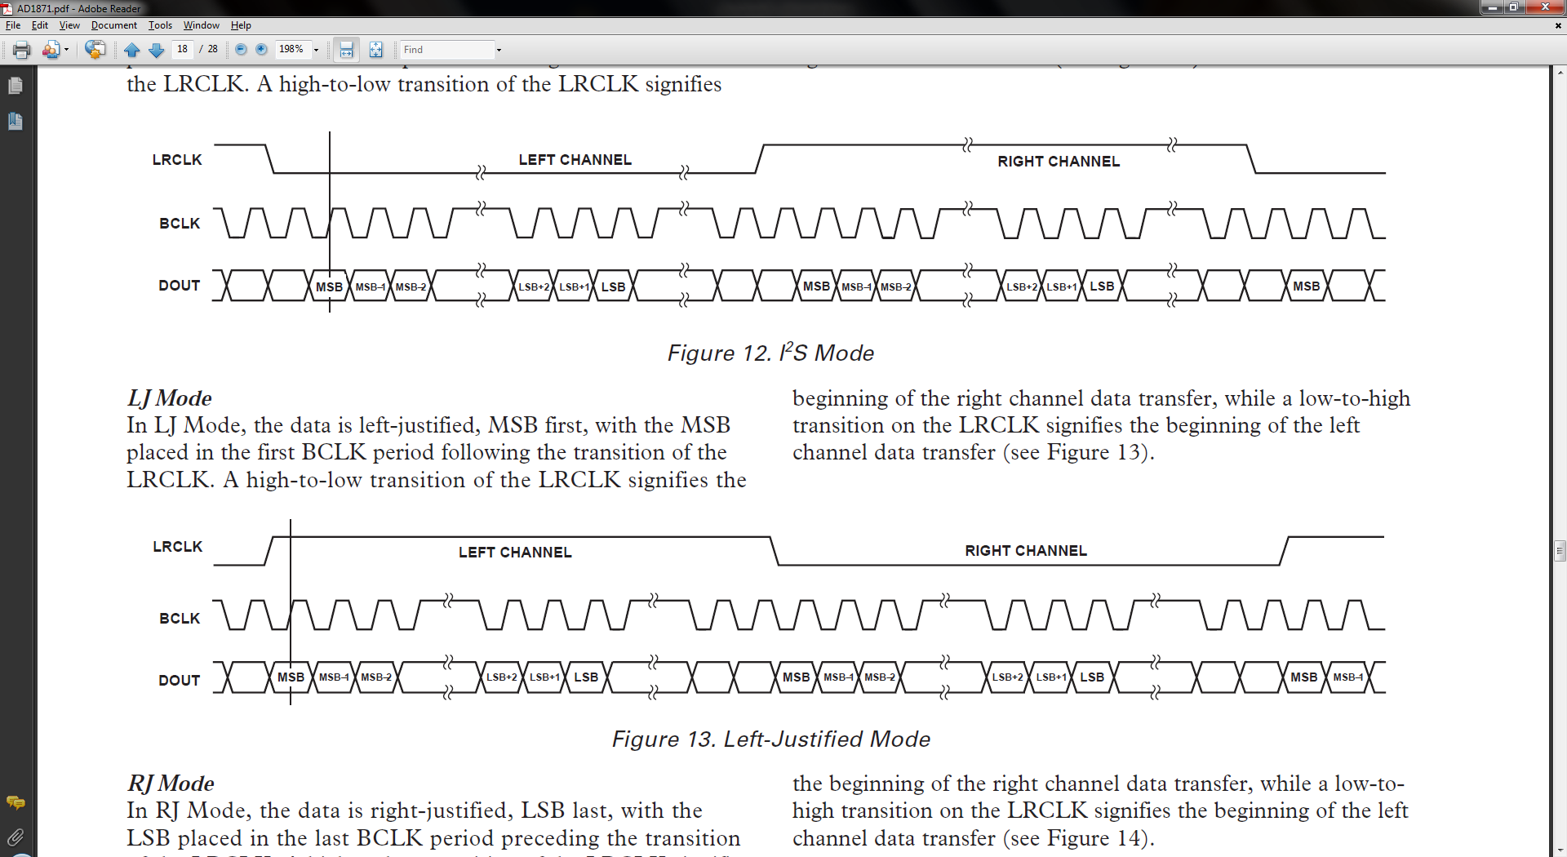

Figure 9: Left-Justified Mode (Figure 13 of AD1871 datasheet [14])

The next stage of the data acquisition system is a Spartan 3-E Field Programmable Gate Array (FPGA) on a Nexys2 development board [15]. The FPGA emulates the communication mode shown in Figure 9 to take in digitized electrode voltage signals.

Once data is captured it is packetized as shown in Table 1. A 2-byte counter is added to each packet based on the 3.072 MHz BCLK coming from the AD1871 to provide a means of determining relative time between samples. The packet control field, shown in Table2, currently only displays whether data is coming from the Left or Right ADC channel and the Data (Control) field, shown in Table 2, provides the channel number for a given set of data. The length is repeated at the end of the packet to provide a basic form of packet validation.

|  |  |  |
| --- | --- | --- |
| **Data Packet Structure** | | |
| **Length (in bytes)** | **Contents** | **Description** |
| 2 | 5A | Start Bytes |
| A5 |
| 1 | Length | Total number of Bytes in packet |
| 2 | Time Counter (MSB) | Two-Byte Counter Incremented by 3.072 MHz BCLK. Counter overflows every 21.3ms. |
| Time Counter (LSB) |
| 1 | Packet Control | Control bits for packet |
| 3 * number of channels in packet | Data (Control) | Control byte for channel and channel data. These three bytes are repeated for each channel contained in the packet. |
| Data (MSB) |
| Data (LSB) |
| 1 | Length | Repeats length to allow packet validation. |

Table 1: Data Packet Structure

|  |  |  |  |  |  |  |  |
| --- | --- | --- | --- | --- | --- | --- | --- |
| **Packet Control** | | | | | | | |
| Bit 7 | Bit 6 | Bit 5 | Bit 4 | Bit 3 | Bit 2 | Bit 1 | Bit 0 |
| Reserved | | | | | | | Left*/Right |
|  |  |  |  |  |  |  |  |
| **Data (Control)** | | | | | | | |
| Bit 7 | Bit 6 | Bit 5 | Bit 4 | Bit 3 | Bit 2 | Bit 1 | Bit 0 |
| Reserved | | Channel | | | | | |

Table 2: Packet Control and Data (Control) fields

Packetized data is sent on to a FTDI FT2232H [16] using its FT245 Asynchronous FIFO mode as shown in Figure 10. Data is placed on the data lines 8 bits at a time by the FPGA. The TXE line is then checked to ensure the FT2232H is ready to receive data. If TXE is low (indicating data can be received) the FPGA will drop WR low causing the FT2232H to read in the 8 bits on the data lines to a 4 Kbyte buffer. This buffer is flushed every 16 ms and the data is passed up to a 64 Kbyte buffer on the PC through USB 2.0.

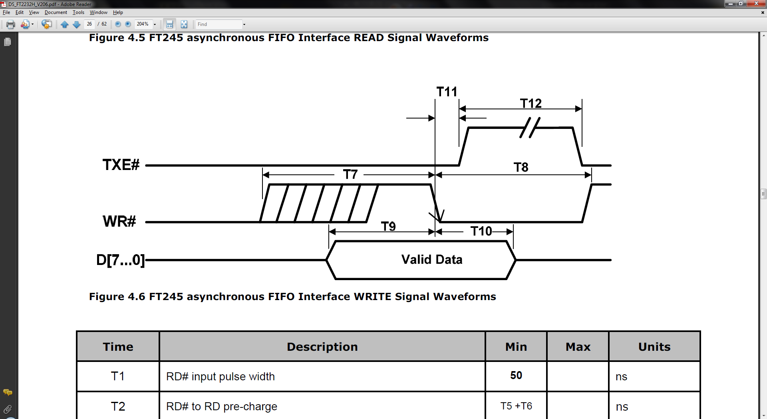

Figure 10: FT245 Asynchronous FIFO Write Interface (Figure 4.5 of FT2232H datasheet [16])

In order to capture and store data passed up to the PC a simple console program was written in C++ that uses the D2XX API provided by FTDI to interface to the FT2232H. This program simply opens a handle for the FT2232H and polls FT_GetStatus to see if any bytes are available in the receive buffer. If there are bytes available the raw packets are read in and stored to file. These files containing raw data packets are then sent through a packet parser that validates the packet and converts the raw data into a voltage for each channel and their corresponding time offset.

## 4.3 Stimulation

The stimulation system allows three methods of MEA electrode stimulation: external, internal user defined, and internal real time. Figure 11 provides the block of the stimulation system.

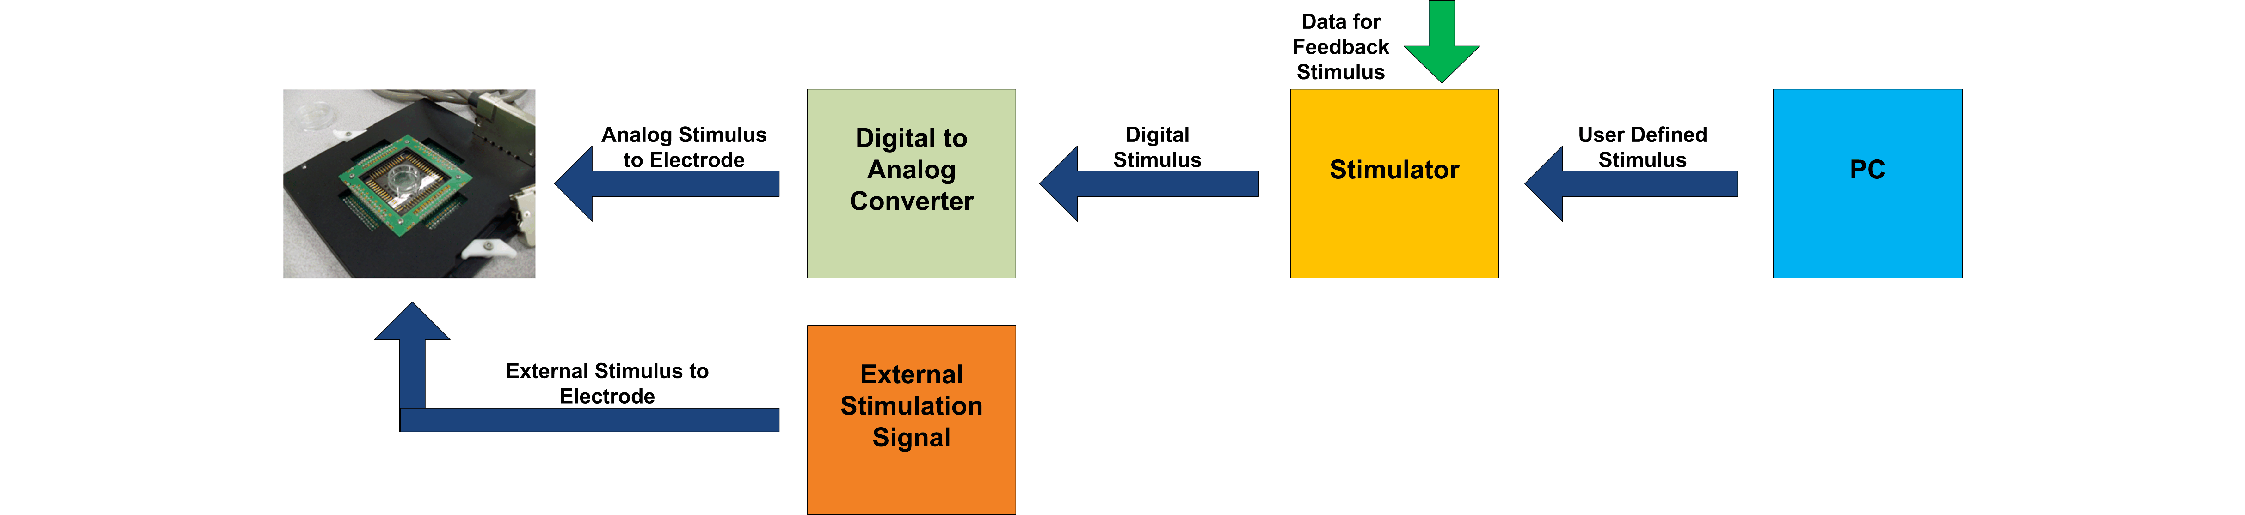

Figure 11: Stimulation Overview

The externally or internally generated stimulation signal is a voltage signal that is sent to an electrode on the MEA. For a given stimulation signal a response could be generated by the cells of the surrounding electrodes. The generated response from the stimulation can be measured by the data acquisition system. Any of the three stimulation modes can be used simultaneously on each of the channels.

Switches on the front of the enclosure control whether the stimulation system is in stimulation or measure mode. External stimulation can be used when an internally generated signal is not required. External stimulation will be input into the system via a BNC jack. The signal input to the system can come from an external source such as a function generator. If the switch is set to stimulation mode then a second switch determines if the system is in internal stimulation or external stimulation. Control signals are sent to the FPGA to control whether it is recording measurement mode or in stimulation mode.

The control signals for the FPGA can be seen in Figure 12. The control signals have to go through the LVC4245A to change the input voltage level from 5V to 3.3V. The FPGA sends control signals to the analog amplifier that control analog switches on the analog amplifier to allow for the analog amplifier to operate in measurement or stimulation mode. When stimulation is selected the input stimulation signal will connect to the analog amplifier where it is input to a summing circuit to obtain the DC offset for the cells inside the MEA. The input external stimulation signal is also input back into the data acquisition circuit to be recorded. Recording the stimulation signal is necessary to know what signal was input into the MEA to match the results recorded on the other channels.

stimulation.wmf

Figure 12: Stimulation Schematic

When internal mode is desired then a real time feedback or user defined stimulation signal can be selected. If user defined stimulations selected the stimulation is software controlled. The stimulation signal is defined by a specified set of commands from a PC. The PC communications to the MCF51JM128 microcontroller on a DEMOJM breakout board through a virtual com port via an USB interface as shown on Figure 12. The commands are sent through the virtual serial port from a text file on the PC that the user defines. The commands control the channel selected, enabling and disabling the channel, the pulsed high voltage of the signal, the pulse width of the signal, and the period in between pulses.

The internal signal generated is typically a pulsed square wave that can pulse a high value at different intervals and varying voltages []. Once the microcontroller receives the data from the user it then selects the channel and sets up an interrupt routine. The interrupt routine will provide the pulse width and period of the signal. When the interrupt is set for the pulse width the microcontroller will send the voltage needed to pulse out to a digital to analog converter (DAC). The DAC is currently using four channels that can be configured for simultaneous stimulation signals. Stimulator systems communication with the DAC is through a SPI interface from the microcontroller to the DAC where the DAC registers can be updated to control the voltage output. Figure 12 shows the pins and locations of the SPI interface from the microcontroller to the DAC. When the microcontroller is in user defined stimulation or real time feedback stimulation control signals will be sent to the FPGA to specify that a certain channel is in stimulation or measurement mode.

If user defined stimulation is not desired the same stimulation system can provide automated stimulation feedback control [6]. The automated feedback system is used in real time to provide feedback stimulation based on the measurement values from measurement mode. The data acquisition system receives the digitized measurement signals from the ADC. These digitized values are then formatted and sent out to a data bus that is connected to the USB to PC. This same data bus can be read in by memory or directly by the microcontroller used in stimulation. The data read into the microcontroller is processed through an algorithm to determine what cells to stimulate or to stop stimulating.  The processing done is based on an algorithm that determines when and which channels to put in stimulation mode and the type of stimulation used.

## 4.4 Physical Implementation

A PCB was designed for the analog circuitry and the digital circuitry was placed inside an aluminum enclosure.

### 4.4.1 Printed Circuit Board

Once the entire analog circuit was simulated and validated using LTspice IV (linear.com), a four layer printed circuit board was designed using PCB123™(www.pcb123.com) (Figure 13). Figure 13 shows two amplification and filter channels. The first stage amplification and filtering circuit is located above the perforation, while the second stage amplification and filtering stage is below. An important aspect of the PCB design was to have the instrumentation amplifier (U2.1, U2.2) as close to the electrode as possible. This specification was the starting point when laying out the design for fabrication.

Also taken into account were the placement of test points and the connectors selected to interface with the digital systems. Test points were placed at the output of each important analog subsystem. Therefore there is a test point at the electrode, IA, summing circuit, integrator, each stage of the Butterworth filter, and at the output of the high pass filter. These test points will allow the user to troubleshoot the circuit more efficiently.

The connectors used for the PCB were selected to ease the connection between the analog and digital systems. Input and output signals are transmitted via miniature SMA to BNC cables. Power (±15V) for the PCB can be connected directly by banana plugs, and control for the switches can be connected via DB-9 cables.

The rest of the design followed from the LTspice IV schematic (Figure 6) and the reference designators correspond to component names accordingly. Some components that do not appear on the LTspice schematic are the .1uF ceramic and 47uF tantalum decoupling capacitors. The .1uF capacitors are used in between the power of the integrated circuits (±15V) and ground, while the 47uF tantalum capacitors are used in between the PCB power and ground layers. These decoupling capacitors are needed to reduce noise and improve the stability of the voltage powering the integrated circuits.



Figure 13 : Two Channel Analog PCB Design produced using PCB123

The different colors on the board relate to the following:

|  |  |
| --- | --- |
| Blue Trace | Traces on Bottom Layer |
| Red Trace | Traces on Top Layer |
| Magenta Polygon | Ground Layer = Inner Layer 1 |
| Dark Blue Polygon | Power Layers = +15, -15 = Inner Layer 2 |
| Red Pads | Solder Footprints on Top Layer |

Table 3: PCB Legend

The footprints for all of the components were developed using PCB123™ and the datasheet for the selected component. These footprints allow a solderable surface for surface mount parts. All of the parts selected are surface mount except for the SMA connectors which are through hole. The SMA connectors were available in surface mount but because of the location of the center pin, a different solder method would have to be used. The parts selected for one channel are in Table 4.

|  |  |  |  |
| --- | --- | --- | --- |
| **Description** | **Manufacturer** | **Manufacturer PN** | **Qty** |
| Instrumentation Amp | Burr-Brown | INA111BU | 1 |
| Dual Operational Amp | Linear Technology | LT1124CS8#PBF | 1 |
| Quad Operational Amp | Linear Technology | LT1125CSW#PBF | 1 |
| Quad Analog Switch | Analog Devices | ADG202AKRZ | 1 |
| 887Ω, 1%, 1/4W | Yageo | RC1206FR-07887RL | 1 |
| 1kΩ, 1%, 1/4W | Yageo | RC1206FR-071KL | 2 |
| 7.68kΩ, 1%, 1/4W | Yageo | RC1206FR-077K68L | 1 |
| 13kΩ, 1%, 1/4W | Yageo | RC1206FR-0713KL | 9 |
| 16.9kΩ, 1%, 1/4W | Yageo | RC1206FR-0716K9L | 3 |
| 19.6kΩ, 1%, 1/4W | Yageo | RC1206FR-0719K6L | 1 |
| 49.9kΩ, 1%, 1/4W | Yageo | RC1206FR-0749K9L | 2 |
| 78.7kΩ,1%, 1/4W | Yageo | RC1206FR-0778K7L | 1 |
| 1100pF 10% 50V | Kemet | GRM2165C1H112JA01D | 6 |
| 0.1µF 10% Ceramic 250v | Kemet | C1206C104KARACTU | 6 |
| 0.47µF 10% Ceramic 50v | Kemet | C1206C474K5RACTU | 2 |
| 47µF Tantalum 35V 20% SMD | Kemet | B45196H6476M509 | 2 |

Table 4: One PCB Channel Analog Parts

### 4.4.2 Enclosure

The entire digital system is contained within an aluminum enclosure. The front of the enclosure can be seen in Figure 14 and the back of the enclosure in Figure 15. The enclosure was designed to minimize user interaction with the digital hardware but still allow maximum system flexibility and control.

Switches on the front of the enclosure allow the user to manually select between measurement/stimulation and external/internal stimulation for each channel. This is done by moving the appropriate switch to the desired position as seen in Figure 14. The front of the enclosure also houses the measurement input, stimulation output, and switch control connectors. Depending on where the switches are positioned, the corresponding input/outputs will be used. The front of the enclosure also has a future switch labeled PC/Manual Control. This switch will allow the digital system to differentiate between PC mode control and manual control. The manual control will be determined by the switches on the enclosure as mentioned before. Next to the PC/Manual Control switch is the power switch and power LED. The LED is powered by the 5V analog supply voltage which is located on the back of the enclosure.

Figure 14: Front of Aluminum Enclosure (labels are rendered)

The external stimulation inputs are located on the back of the enclosure. This input will allow the user to connect an external source such as a function generator directly to the system and stimulate the electrode in this way. The back of the enclosure also has 4 USB ports which can be used to connect to the FPGA, FTDI chip and stimulator microcontroller via PC. In the bottom right had corner of the enclosure are the digital and analog power inputs. The digital system is driven by 3.3V and 5V. Since some of the digital hardware requires both analog and digital voltages, there are separate voltage supply ports for each along with separate digital and analog ground.

Figure 15: Back of Aluminum Enclosure (labels are rendered)

# 5. System Validation

The designed system was tested in order to verify its functionality. Both the analog and digital systems were tested independently and once results were verified, full system tests were performed. An overview of each test and the specification that it validates is shown in Table 5.

|  |  |  |  |  |  |  |  |  |  |  |  |  |
| --- | --- | --- | --- | --- | --- | --- | --- | --- | --- | --- | --- | --- |
| **Specification** | **Description** |  | **Inspection** | **PCB Design** | **5.1.1 Frequency Response** | **5.1.2 DC Settling Time** | **5.1.3 Basic Functionality** | **5.1.4 Operational Functionality** | **5.1.5 Noise/Offset** | **5.2.1 Data Acquisition** | **5.3.1 User-Defined Stimulation** | **5.4.1 Recording of User-Defined Stimulation** |
| 3.1.1 | Low-Noise |  |  |  |  |  |  |  |  |  |  |  |
| 3.1.2 | 1000V/V passband gain |  |  |  | C:\Users\Kyle\Desktop\School\Senior Design\Presentation\Check Mark.gif |  |  |  |  |  |  |  |
| 3.1.3 | 20 Hz to 20 kHz passband |  |  |  | C:\Users\Kyle\Desktop\School\Senior Design\Presentation\Check Mark.gif |  |  |  |  |  |  |  |
| 3.1.4 | Use IA |  | C:\Users\Kyle\Desktop\School\Senior Design\Presentation\Check Mark.gif | C:\Users\Kyle\Desktop\School\Senior Design\Presentation\Check Mark.gif |  |  |  |  |  |  |  |  |
| 3.1.5 | IA must not saturate |  |  |  |  |  |  |  |  |  |  |  |
| 3.1.6 | Test Points |  | C:\Users\Kyle\Desktop\School\Senior Design\Presentation\Check Mark.gif | C:\Users\Kyle\Desktop\School\Senior Design\Presentation\Check Mark.gif |  |  |  |  |  |  |  |  |
| 3.2.1 | User-Defined Stim |  |  |  |  |  |  |  |  |  | C:\Users\Kyle\Desktop\School\Senior Design\Presentation\Check Mark.gif |  |
| 3.2.2 | External Stim |  |  |  |  |  |  |  |  |  |  |  |
| 3.2.3 | 48 kSamples/Channel |  |  |  |  |  |  |  |  | C:\Users\Kyle\Desktop\School\Senior Design\Presentation\Check Mark.gif |  | C:\Users\Kyle\Desktop\School\Senior Design\Presentation\Check Mark.gif |
| 3.2.4 | 16-bit resolution |  |  |  |  |  |  |  |  | C:\Users\Kyle\Desktop\School\Senior Design\Presentation\Check Mark.gif |  | C:\Users\Kyle\Desktop\School\Senior Design\Presentation\Check Mark.gif |
| 3.2.5 | 30 minutes recorded |  |  |  |  |  |  |  |  |  |  |  |
| 3.2.6 | Real-Time stim |  |  |  |  |  |  |  |  |  |  |  |
| 3.3.1 | Selectable Meas/Stim |  |  |  |  |  |  |  |  | C:\Users\Kyle\Desktop\School\Senior Design\Presentation\Check Mark.gif |  | C:\Users\Kyle\Desktop\School\Senior Design\Presentation\Check Mark.gif |
| 3.3.2 | Default to Meas |  |  | C:\Users\Kyle\Desktop\School\Senior Design\Presentation\Check Mark.gif |  |  |  |  |  |  |  |  |
| 3.3.3 | Support 4, expand to 60 |  | C:\Users\Kyle\Desktop\School\Senior Design\Presentation\Check Mark.gif | C:\Users\Kyle\Desktop\School\Senior Design\Presentation\Check Mark.gif |  |  |  |  |  |  |  |  |
| 3.3.4 | Self-Test |  |  |  |  |  |  |  |  |  |  |  |
| 3.3.5 | Power Indicator |  | C:\Users\Kyle\Desktop\School\Senior Design\Presentation\Check Mark.gif | C:\Users\Kyle\Desktop\School\Senior Design\Presentation\Check Mark.gif |  |  |  |  |  |  |  |  |
| 3.3.6 | Flexibility |  | C:\Users\Kyle\Desktop\School\Senior Design\Presentation\Check Mark.gif | C:\Users\Kyle\Desktop\School\Senior Design\Presentation\Check Mark.gif |  |  |  |  |  |  |  |  |
| 3.3.7 | Interface to fixture |  | C:\Users\Kyle\Desktop\School\Senior Design\Presentation\Check Mark.gif | C:\Users\Kyle\Desktop\School\Senior Design\Presentation\Check Mark.gif |  |  |  |  |  |  |  |  |

Table 5: Validation Matrix (shading indicates untested)

## 5.1 Low-Noise Amplification and Filtering

The low-noise amplification and filtering tests will verify the specifications of the analog circuitry. The characteristics of the instrumentation amplifier, integrator circuit, summing circuit, Butterworth filter, and high pass filter will be tested. These tests will validate the performance of each sub circuit and provide insight into the limitations of the functional analog circuit.

1. **Frequency Response (Pre-Amplifier and Amplifier)**

Purpose: To confirm the magnitude and frequency response of the first and second stage amplification and filtering circuits in measurement mode.

Procedure:

1. Apply a sinusoidal voltage signal of no larger than 15mV peak-to-peak at the V+IN pin with respect to GND of the instrumentation amplifier using a waveform generator. Measure peak-to-peak amplitude with an oscilloscope.
2. The peak-to-peak output voltage signal from the amplifier is measured with an oscilloscope.
3. Obtain simulated magnitude Bode plot for actual component values.
4. Tabulate gain between DC and 1MHz. Plot points on simulated and ideal Bode plot.
5. Determine the -3dB and -.5dB bandwidths and maximum passband ripple.

Results:

The simulation results in Figure 17 were obtained from LTspice IV test parameters described in Figure 16. The simulation results and experimental results from the PCB can be seen in Figure 18.

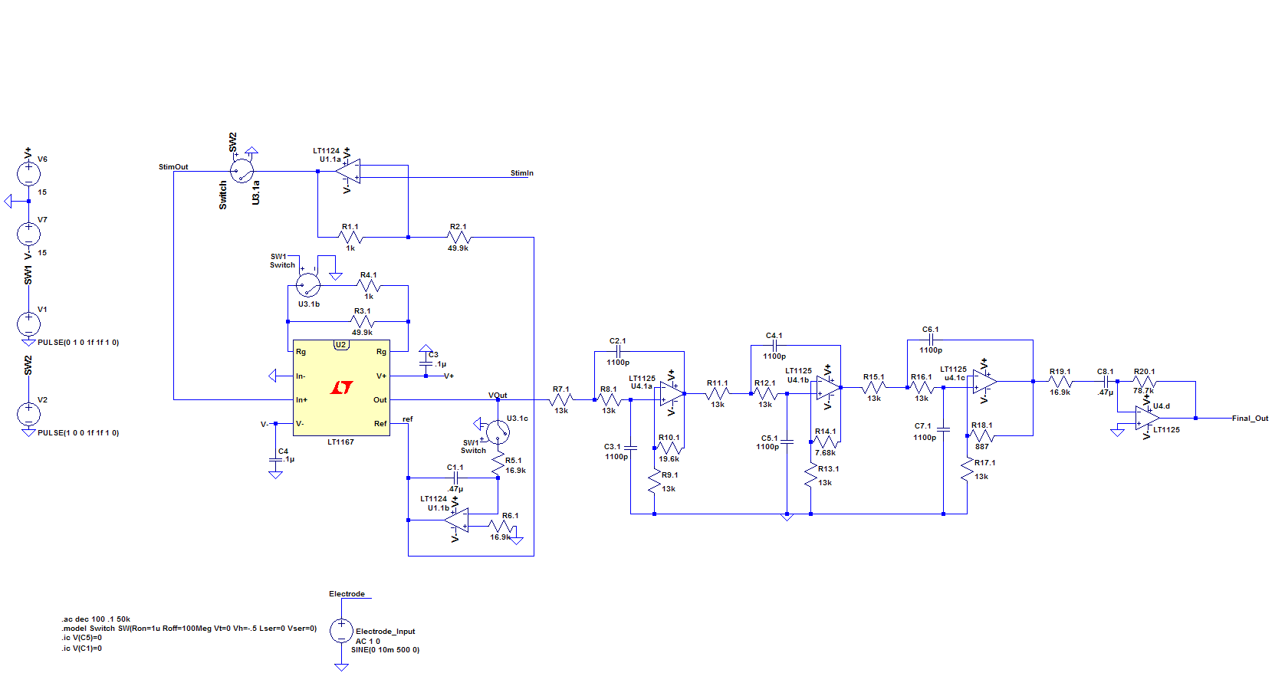

Figure 16: Bode Plot Simulation Parameters



Figure 17: Simulated Amplifier Gain and Phase Frequency Response

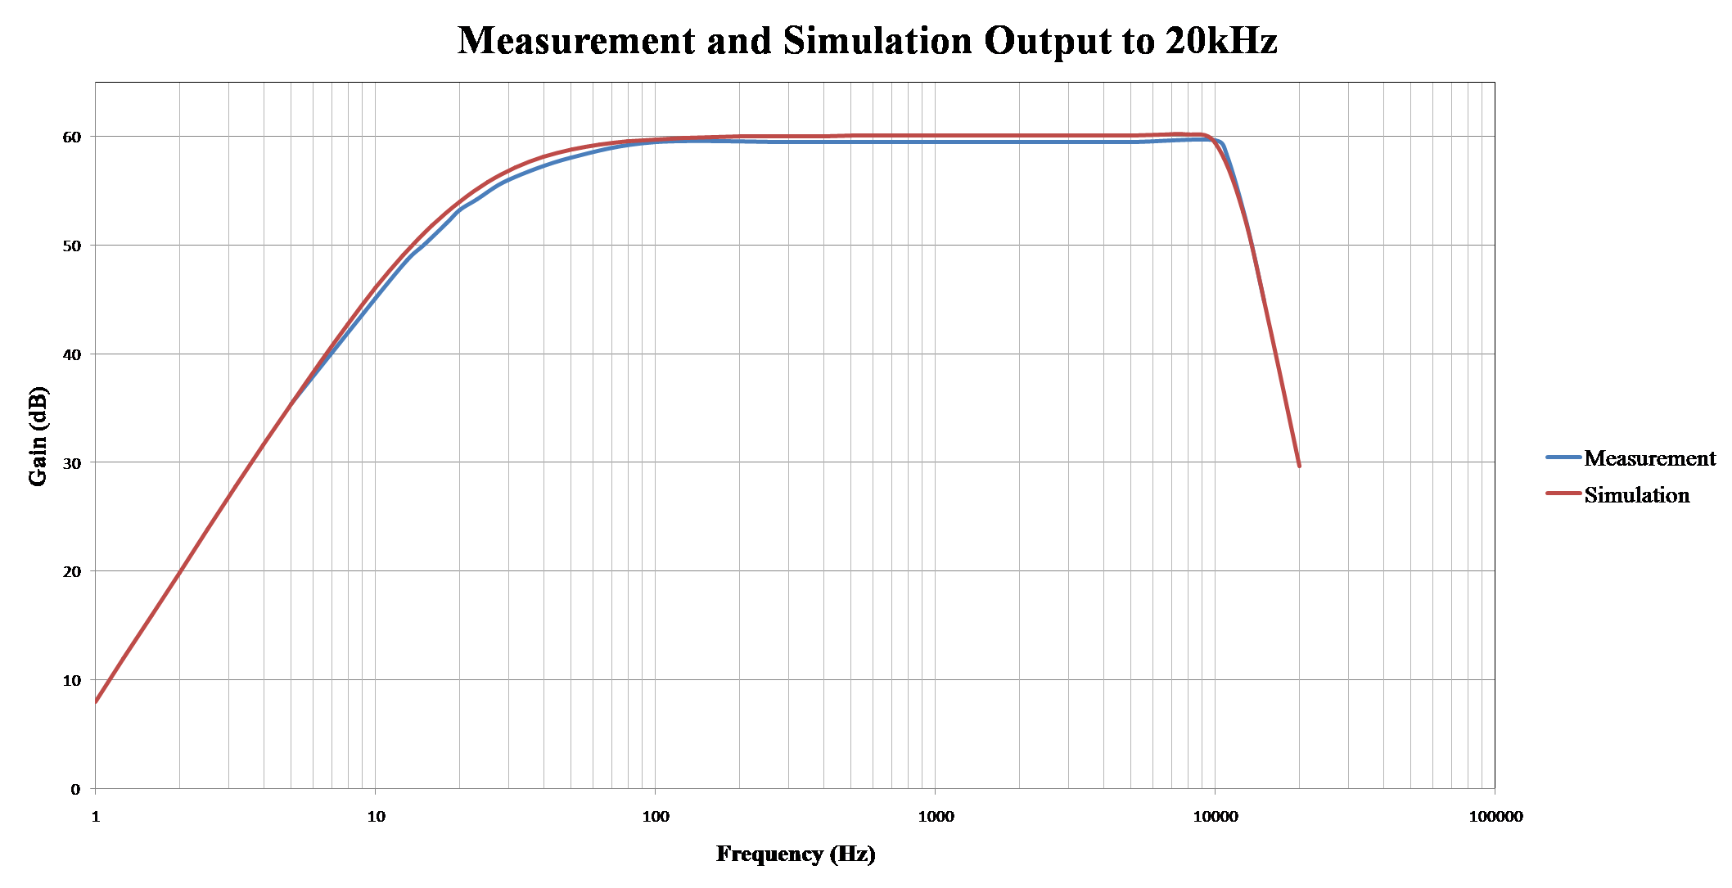

Figure 18: Simulation vs. Experimental Gain Frequency Response

From Figure 18, the simulation and experimental results are very close to each other. This validates the initial design. The first corner frequency is around 20Hz and the gain is nearly 60 dB which relates to 1000V/V. One thing to note is that the second corner frequency is near 10kHz and not the calculated 20kHz. Also the actual gain of the system is 943 V/V and not the calculated 991.94 V/V.

1. **DC Settling Time (Pre-Amplifier in Measurement Mode)**

Purpose: To determine how long the pre-amp requires to settle to a new DC input level.

Procedure:

1. Apply a voltage square wave signal of ±100mV at the V+IN pin with respect to GND at the instrumentation amplifier using a waveform generator.
2. The square wave voltage input and the voltage output of the instrumentation amplifier is displayed with an oscilloscope.
3. Set the period of the square wave so that the circuit reaches steady state.
4. Measure the time required for the instrumentation amplifier output to settle to within 10% of its final value relative to the square wave edge transition for both input levels.

Results :

The test was run as described above with Agilent 3320A Waveform Generator. The input signal can be seen on CH1 of Figure 19 as a 100mVpp, 10kHz, 50% duty cycle square wave. The output can be seen on CH2. The time for the capacitor to charge to 90% of the maximum DC level was measured with the cursor function of the Tektronix TDS210 oscilloscope. The time found was 640ns. The time for the capacitor to charge to 100% of maximum DC level was also measured but is not shown in Figure 19. The value measured with the cursor function for this test was found to be 1.24µs.

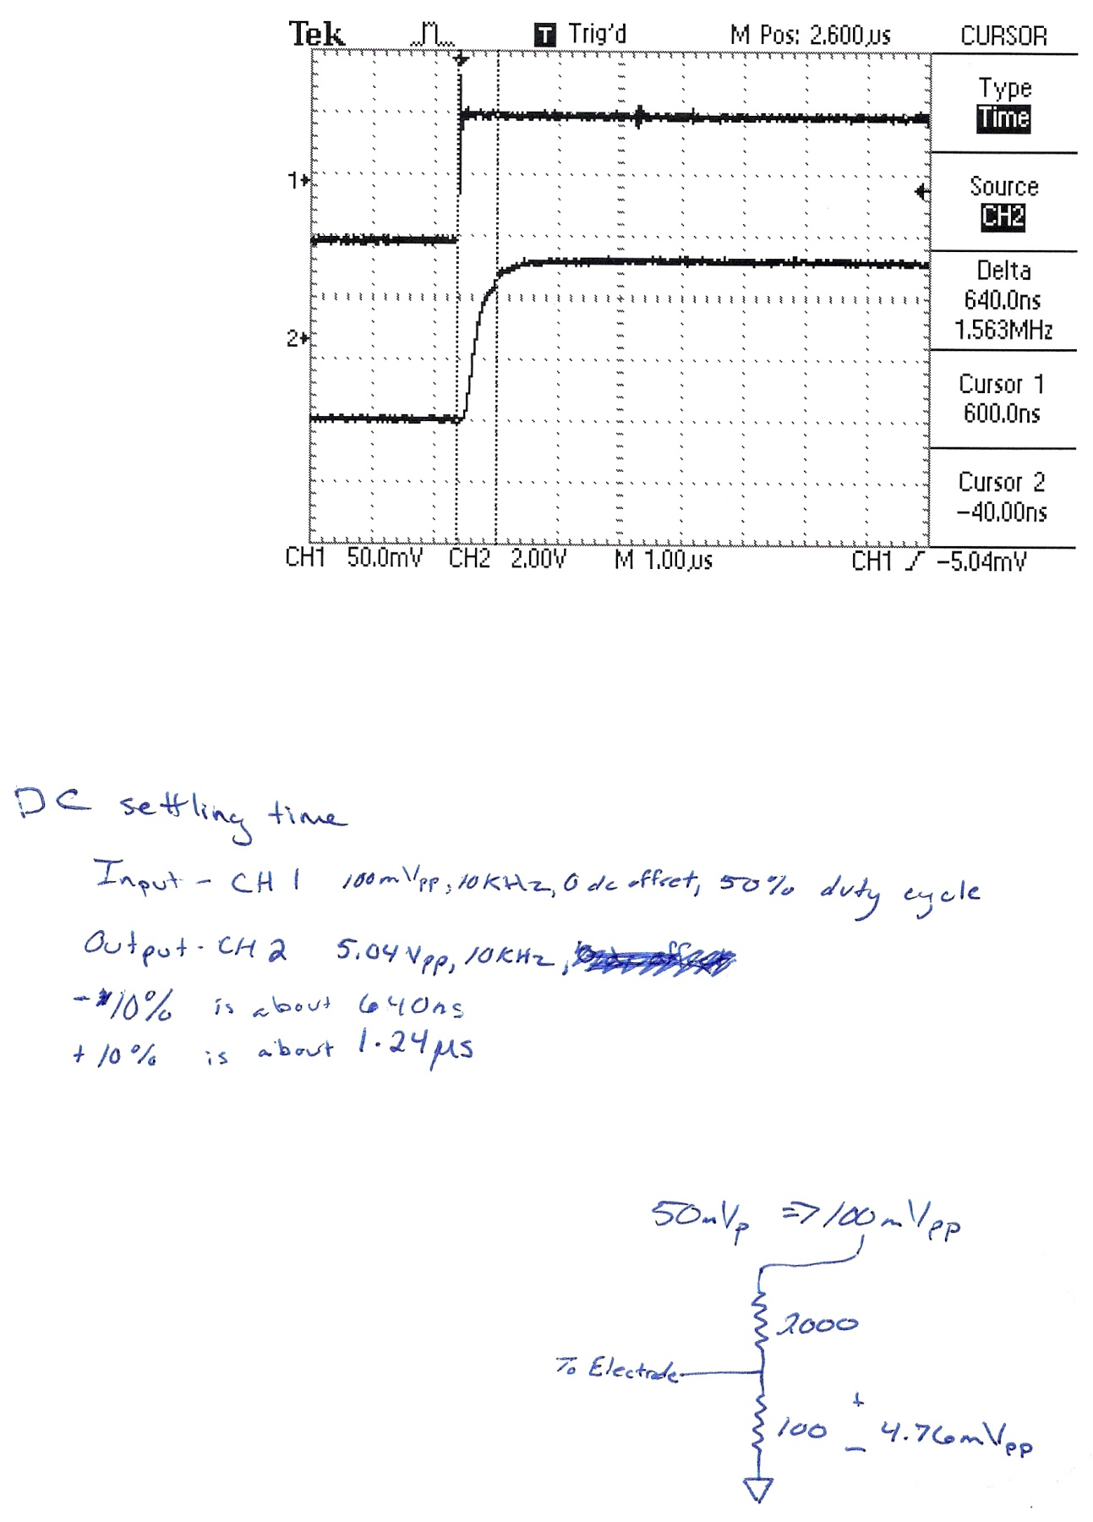

Figure 19: DC Settling Time Test Results via Tektronix TDS210 oscilloscope

1. **Basic Functionality**

Purpose: To check the basic functionality of stimulation mode.

Procedure:

1. Analog system is in stimulation mode.
2. V-IN pin of the instrumentation amplifier is grounded.
3. Apply a 1kHz 1Vpp sinusoidal signal with respect to GND at the stimulation input of the summing circuit.
4. Verify output at the electrode is a 1kHz 1Vpp sinusoidal signal.

Results :

The first stage amplification and filtering circuit was switched into stimulation mode and the output was recorded using a Tektronix TDS210 oscilloscope. The input/output can be seen in Figure 20. The stimulation signal input is seen on CH1 and the output at the electrode is seen on CH2. As expected the input and output signals are about the same, with a 20mV error.

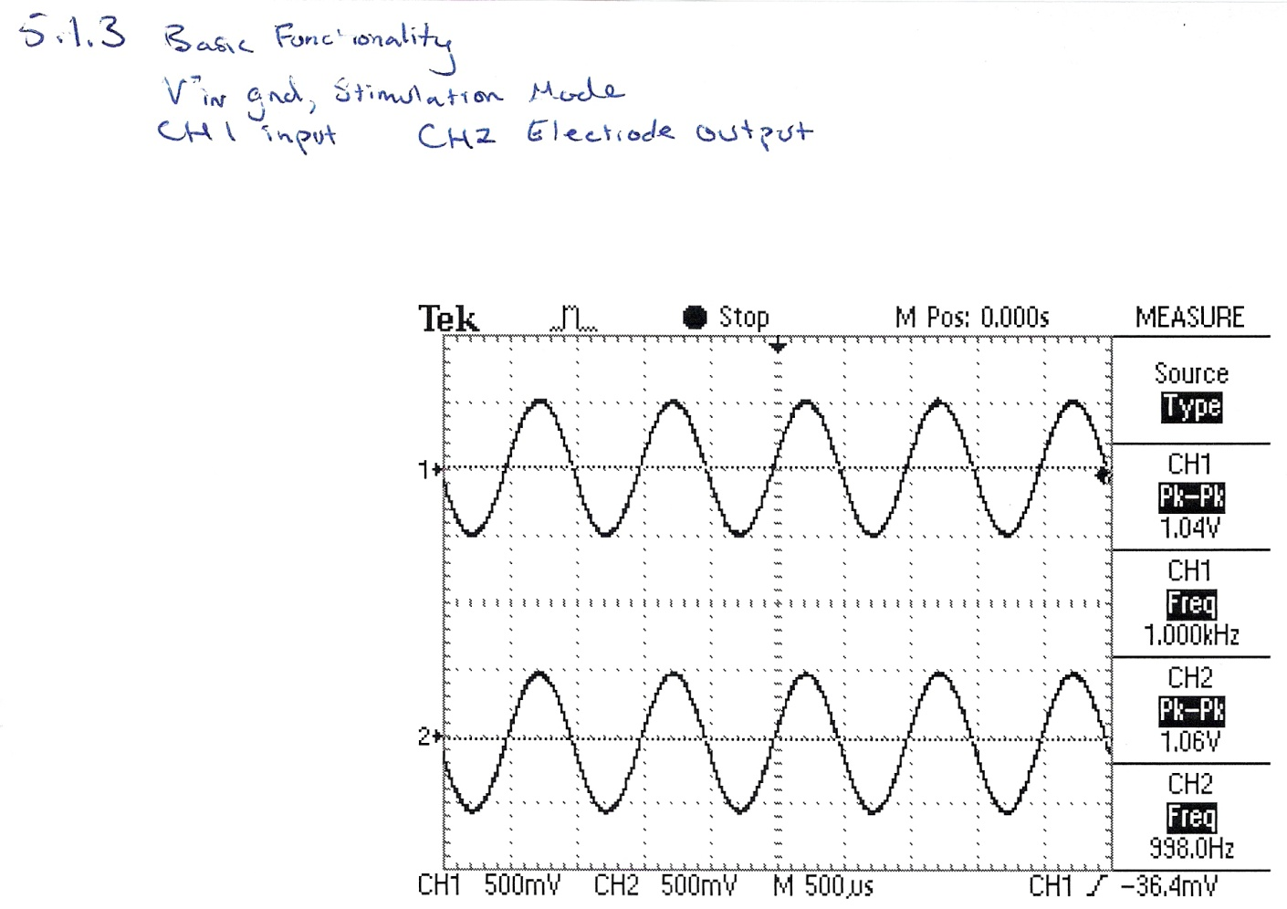

Figure 20: Basic Functionality Test Result via Tektronix TDS210 oscilloscope

1. **Operational Functionality**

Purpose: Check basic functionality of measurement and stimulation mode. Measure integrator capacitor droop rate.

Procedure:

1. A 1kHz 10mVpp sinusoidal signal with 100mV DC offset with respect to GND is applied at the V+IN pin of the instrumentation amplifier in measurement mode.
2. A 100Hz 1Vpp sinusoidal stimulation signal with respect to GND is applied at the stimulation input in stimulation mode.
3. Apply a square wave to switch the circuit between measurement and stimulation mode. Note: Only the corresponding signal and mode should be operating at once.
4. Verify a 1kHz 10mVpp sinusoidal signal with 100mV DC offset at V+IN pin of the instrumentation amplifier. For measurement mode, verify a 1kHz 10Vpp sinusoidal signal at the output of the high pass filter.
5. For stimulation mode, verify a 100Hz 1Vpp sinusoid with 100mV DC offset at the electrode with respect to GND. Verify a 2Vpp sinusoid at the output of the instrumentation amplifier.
6. Display electrode voltage with respect to GND using an oscilloscope. Trigger on square wave mode to select signal. Capture the plot.
7. Display amplifier output voltage with respect to GND using oscilloscope trigger.
8. Increase period of square wave to 1Hz. Display voltage at output of integrator circuit with respect to GND with oscilloscope from transition to stimulation mode. Measure rate of voltage drop. Capture plot

### Noise/Offset (Pre-Amplifier and Amplifier)

The noise/offset tests were not completed. The procedure for each mode is described below.

Purpose: Characterize overall amplifier noise.

Procedure:

1. Ground all inputs. Place system in measurement mode.
2. Obtain output voltage spectrum with respect to GND of pre-amp and amplifier output.
3. Determine RMS value.
4. Stimulation Mode

Purpose: To measure output noise of the circuit when in stimulation mode.

Procedure:

1. Ground all inputs.
2. Obtain noise spectrum.
3. Obtain RMS value.

## 5.2 Data Acquisition

* 1. **Data Acquisition**

Purpose: To confirm the correct operation of the data acquisition system.

Procedure:

1. Apply two different sinusoidal voltage signals of varying frequencies into both channels of the ADC.
2. Capture the two signals on an oscilloscope.
3. Capture the two signals to the PC.

Results:

Figure 21 shows the two signals on an oscilloscope and Figure 22 shows these same two signals captured using the data acquisition system. The frequency, minimum voltage and maximum voltage are given directly below their corresponding figure. The Channel 1 frequency results show a close match between the oscilloscope and PC results. The Channel 3 frequency results show a close match between the oscilloscope and PC results, however, there is a 0.035 kHz difference due to the frequency being found by using sampled points which have a precision of 21us. The voltage levels for each channel are off due to a known offset realized by the A/D.

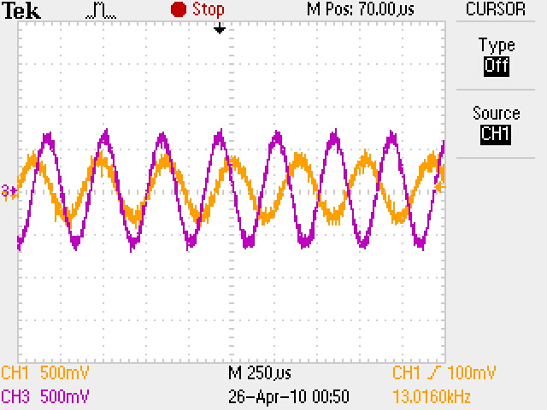

Figure 21: Oscilloscope Results via Tektronix TDS2024B

Channel 1: 2.50 kHz, -300mV to 480mV

Channel 3: 2.941 kHz, -660mV to 640mV

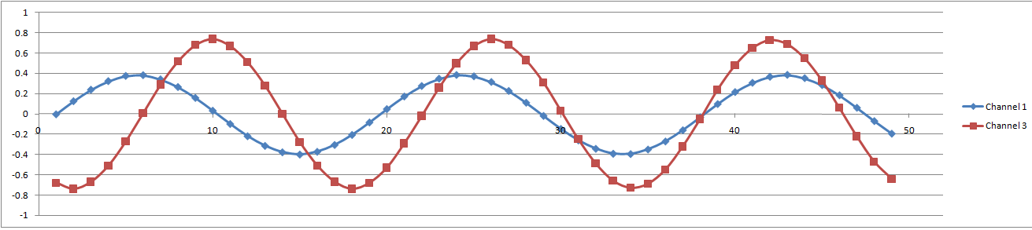

Figure 22: PC Results

Channel 1: 2.506 kHz, -397mV to 383mV

Channel 3: 2.976 kHz, -740mV to 740mV

**5.3 Stimulation**

1. **User-Defined Stimulation**

Purpose: Verify User-Defined Stimulation for four channels

Procedure:

1. Set up user defined stimulation on four channels.
2. Capture output on oscilloscope.

Results:

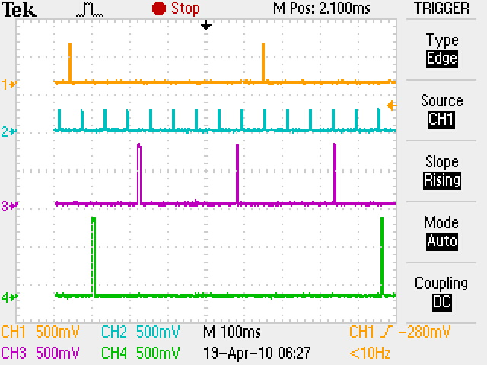

Figure 23: User-Defined Stimulation via Tektronix TDS2024B oscilloscope

## 5.4 Full System Integration

### 5.4.1 Recording of User-Defined Stimulation

Purpose: Verify stimulation signals are successfully recorded.

Procedure:

1. Configure user-defined stimulation on Channel 2.
2. Connect the stimulation BNC on Channel 2 to the measurement BNC on Channel 1.
3. Record data from both channels and show the stimulation data from Channel 2 was captured and matches the data taken in on Channel 1.

Results:

The stimulation signal is recorded and matches the measured signal on Channel 1 (see Figure 24).

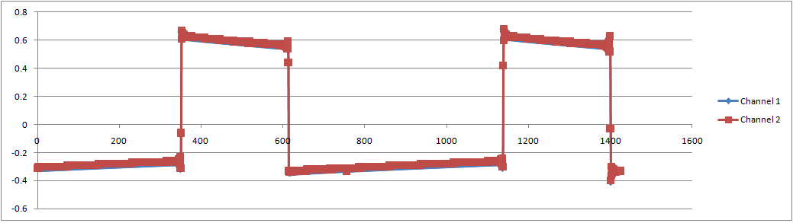

Figure 24: Recording of User-Defined Stimulation

# 6. Conclusions

The overall system still needs improvements in order to meet all of the specifications desired; nevertheless this project has provided the core elements required for a fully functional prototype. Tests have shown each subsystem is functional with most intended features. The next step is combining the analog, data acquisition, and stimulation subsystems together into a functional prototype. Recommendations have been provided in the following section as guidance for future improvements.

# 7. Recommendations

The following are recommendations to improve overall system performance:

* An appropriate noise figure specification should be investigated based on initial work [].
* Investigate and fix packet error rate from the FPGA.
* Investigate and fix analog to digital offset.
* Implement software control.
* Expand the number of channels supported.
* Design an internal power supply for the digital system within the enclosure.
* Design an enclosure for the amplification/filtering circuit.
* Investigate source of error in Butterworth filter corner frequency.
* Implement real-time stimulation

# 8. Budget

The overall approximate cost of the project is in Table 6. Financial assistance was provided by WMU Siebert Undergraduate Research and Creative Activities Award Program ($1000 for project expenses), Michigan Space Grant Consortium (Kyle Batzer undergraduate research fellowship), Sunstone Circuits ($100 PCB credit), and Drs. Damon Miller (components) and Frank Severance (components). Refer to Appendix 0 for a parts list with purchase prices.

|  |  |
| --- | --- |
| **Cost Breakdown** | |
| **Description** | **Amount** |
| PCB | $279.80 |
| PCB Credit | -$100.00 |
| Digital Components | $252.11 |
| Enclosure/Components | $241.72 |
| Analog Components | $432.18 |
| **Total** | $1,105.81 |

Table 6: Cost Summary (approximate)

# 9. References

[1] T. Caruso, E. Daiek, and E. Jones, “Low Noise Amplification and Stimulation System for Neural Multi-Electrode Arrays,” WMU Department of Electrical and Computer Engineering Senior Design Project, December 2009.

[2] E.Armstrong, J. P. John, N. McCaskey, A. Ranganathan, P. Vandeusen, and S. Westbrooks, “Real-Time Feedback Control of Neuron Cell Culture Electrical Activity,” WMU Department of Electrical and Computer Engineering Senior Design Projects, December 2007.

[3] J. Stahl, “Dual Channel Low Noise Amplifier for Experiments in Neurophysiology,” WMU Master of Science in Electrical Engineering, June 2009.

[4] M. Ellinger, “Acquisition and Analysis of Biological Neural Network Action Potential Sequences,” WMU Master of Science in Electrical Engineering, June 2009.

[5] Y. Jimbo, N. Kasai, K. Torimitsu , T. Tateno, and H. P.C. Robinson, “A system for MEA-based multisite stimulation,” *IEEE Transactions on Biomedical Engineering*, vol. 50, no. 2, pp. 241-248, Feb 2003.

[6] S. M. Potter, D. A. Wagenaar, and T. B. DeMarse, (2005). “Closing the Loop: Stimulation Feedback Systems for Embodied MEA Cultures” in Advances in Netwrok Electrophysiology Using Multi-Electrode Arrays.

[7] S. Marom and G. Shahaf, “Development, Learning and Memory in Large Random Networks of Cortical Neurons: Lessons Beyond Anatomy,” *Quarterly Reviews of Biophysics*, vol. 35, pp. 63-87, 2002.

[8] S. Freeman, (2005). *Biological Science* (2nd Ed). Prentice Hall.

[9] G. R. Cooper and C. D. McGillem, (1998). *Probabilistic Methods of Signal and System Analysis* (3rd Ed). Oxford University Press.

[10]  *LT1167 Single Resistor Gain Programmable, Precision Instrumentation Amplifier Datasheet,”* Linear Technologies [Online], 29 April 2010. Available: http://cds.linear.com/docs/Datasheet/1167fa.pdf

[11] *LT1124/LT1125 Dual Quad Low Noise, High Speed Precision Op Amps Datasheet*,” Linear Technologies [Online], 15 October 2009. Available: http://cds.linear.com/docs/Datasheet/11245fc.pdf

[12] *INA111 High Speed FET-Instrumentation Amplifier* *Datasheet*, Texas Instruments [Online], 15 October 2009. Available: http://focus.ti.com/lit/ds/symlink/ina111.pdf.

[13] Budak, A. (1974). *Passive and Active Network Analysis and Synthesis*. Boston, MA: Houghton Mifflin Company

[14] *AD1871 Datasheet*, Analog Devices [Online], August 20, 2009. Available: http://www.analog.com/static/imported-files/data_sheets/AD1871.pdf.

[15] *Digilent Nexys2 Board Reference Manual*, Nexys2 [Online], 21 June 2008. Available: http://www.digilentinc.com/Data/Products/NEXYS2/Nexys2_rm.pdf.

[16] *FT2232H Datasheet*, FTDI [Online], November 20, 2009. Available: http://www.ftdichip.com/Documents/DataSheets/DS_FT2232H.pdf

[17] S. M. Potter, and D. A. Wagenaar, “A Versatile All-Channel Stimulator for Electrode Arrays, with Real-Time Control,” *Journal of Neural Engineering*, vol. 1, pp. 39-45, 2004.

**10. Project Materials**

The CD contains the following materials:

* PCB123™ Design/Libraries
* Analog/Digital Datasheets
* Digital Code
* LTspiceIV Schematics
* Final Report

# 11. Appendices1

11.1 11.1 Freescale Semiconductor CodeWarrior Software User Guide

11.2 11.2 Xilinx ISE Design Suite for a Digilent Nexys2 FPGA Board User Guide

11.3

11.4 11.4 Parts List

## 11.1 Freescale Semiconductor CodeWarrior Software User Guide

CodeWarrior for Coldfire V1 User Guide:

Install software for CodeWarrior Development Studio for Microcontrollers and Install P&E micro DemoBoard Toolkit. Codewarrior is the Integrated Development Environment for Coldfire microcontrollers that include the P&E Multilink USB debugger.

**Opening Project:**

1. Open ColdWarrior: Start->Programs->Freescale CodeWarrior->CodeWarrior IDE
2. Load Project: File->Open
   1. Navigate to project folder i.e C:\Documents and Settings\ece_lab\My Documents\Stimulation
   2. Open file with .mcp extension i.e stimulation.mcp
3. In order to flash and run program on the DEMOJM board ensure drop down box on left is set to “P&E Multilink/Cyclone Pro” shown in Figure 1.

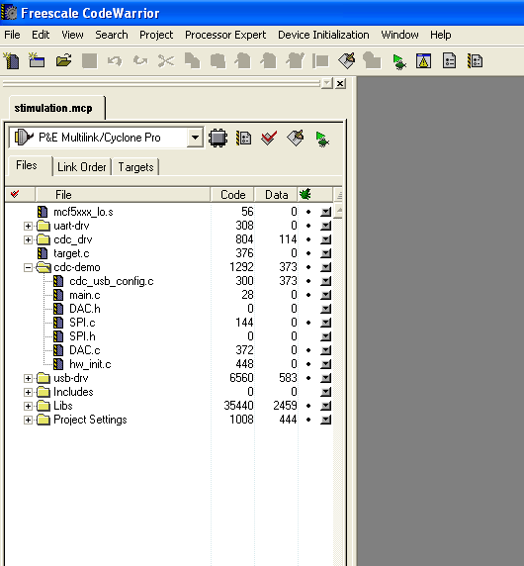

Figure 1

1. Make the program with the  to compile and link the program.
2. After successful compile of program it can be flashed and debugged with . This will allow for debugging but also will flash the memory so the Coldfire can be ran off flash.
3. Debug menu will bring up another window press the  and select ok.
4. To start the program with debugging select .
5. To stop select  or to reset select .
6. In the debug window there are six separate windows. “Source” window displays the code along with the ability to right click and add breakpoints on any line of code. Also “Assembly” this shows the breakdown of the code into assembly instructions. “Data1” window that displays global variables. “Data2” which shows the local variables for the running method. “Register” and “Memory” which show the data in memory. “Command” which shows the commands when the debugger starts and stops along with the running frequency of the chip.

**Creating a new project:**

1. Open ColdWarrior: Start->Programs->Freescale CodeWarrior->CodeWarrior IDE
2. Load Project: File->New Project
   1. Wizard Map will show: Select MCF51JM128 and P&E Multilink/Cyclone Pro
   2. Hit next
   3. Name your project and select a location, hit Next when done
   4. Add files to project like included files. Hit Next and Next again.
   5. Finish
3. Double click on main.c to open main method and begin programming. Please reference the reference manual for MCF51JM128 here: <http://www.freescale.com/files/32bit/doc/ref_manual/MCF51JM128RM.pdf>.

**Create a new USB to Virtual COM project:**

Note this is different than creating a new project because this is the only way we could get the files to link properly when compiling for a virtual com port.

1. Copy the cdc-demo folder from the CMXUSB_LITE_V1 examples folder to any location. Located at C\CMX_USB_LITE_V1\usb-peripheral\projects\CodeWarrior-6.x\mcf51xx\cdc-demo
2. Once copied you can rename the .mcp file to your new project name along with the folder name and you can delete the “cdc_main.c” and add a new “main.c” file for the main method.
3. Open projects using steps 1-3 from opening project.
4. Once open new include files can be added by right clicking on the left side in the project manager and selecting add files.
5. Now you should be able to use usb functions to write your own main method.

To use the DEMOJM board usb mini connection as a CDC the correct .inf should be used. There are two separate .inf one for windows XP and another for Windows 7. Please refer to the cd for those files. First time use instructions.

1. Connect mini usb to DEMOJM and also to PC.
2. Run the CDC virtual com program is running on the board.
3. Windows should say pop up with new device and load a install window.
4. To install the driver select from location and select the folder with the corresponding .inf file.
5. Windows should see the file and install the driver for use on the PC.

## 11.2 Xilinx ISE Design Suite for a Digilent Nexys2 FPGA Board User Guide

**Opening and Modifying a Project:**

1. Open ISE Project Navigator: Start -> Programs -> Xilinx ISE Design Suite 11 -> ISE -> Project Navigator
2. Select File -> Open Project…

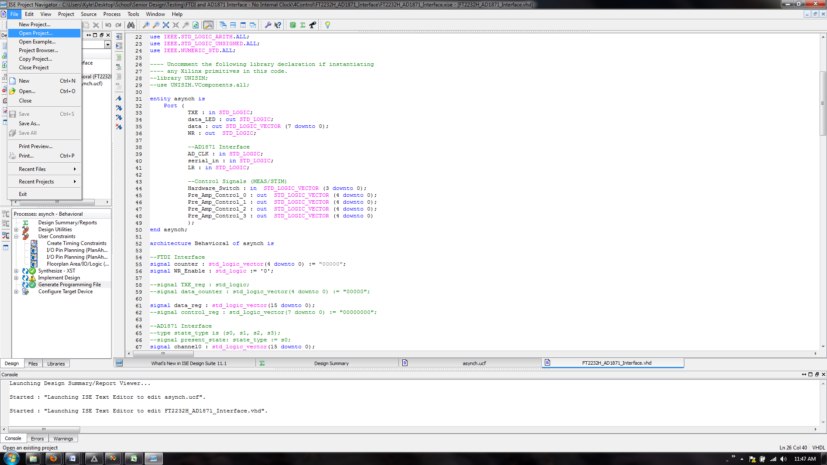

Figure 1: Open Project

1. A window will pop up that allow you to select the project to open. Project files have the extension .xise.

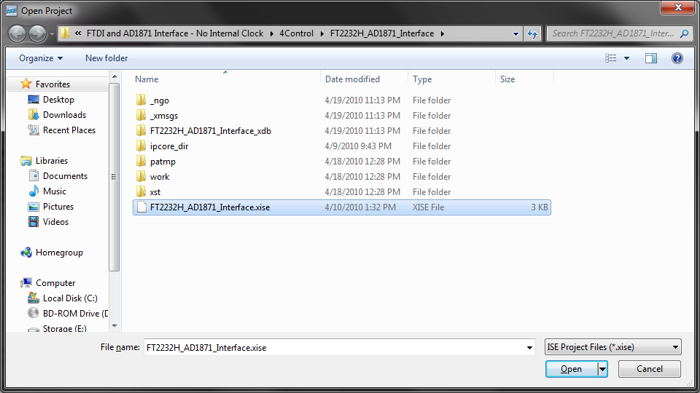

Figure 2: Open Project

1. Upon opening a project its Design Summary will show. To access the .vhdl file for the project double click the .vhdl file under the Design Hierarchy (shown as the selected item in Figure 3). Note that the drop down menu “Sources for” should be set to Implementation.

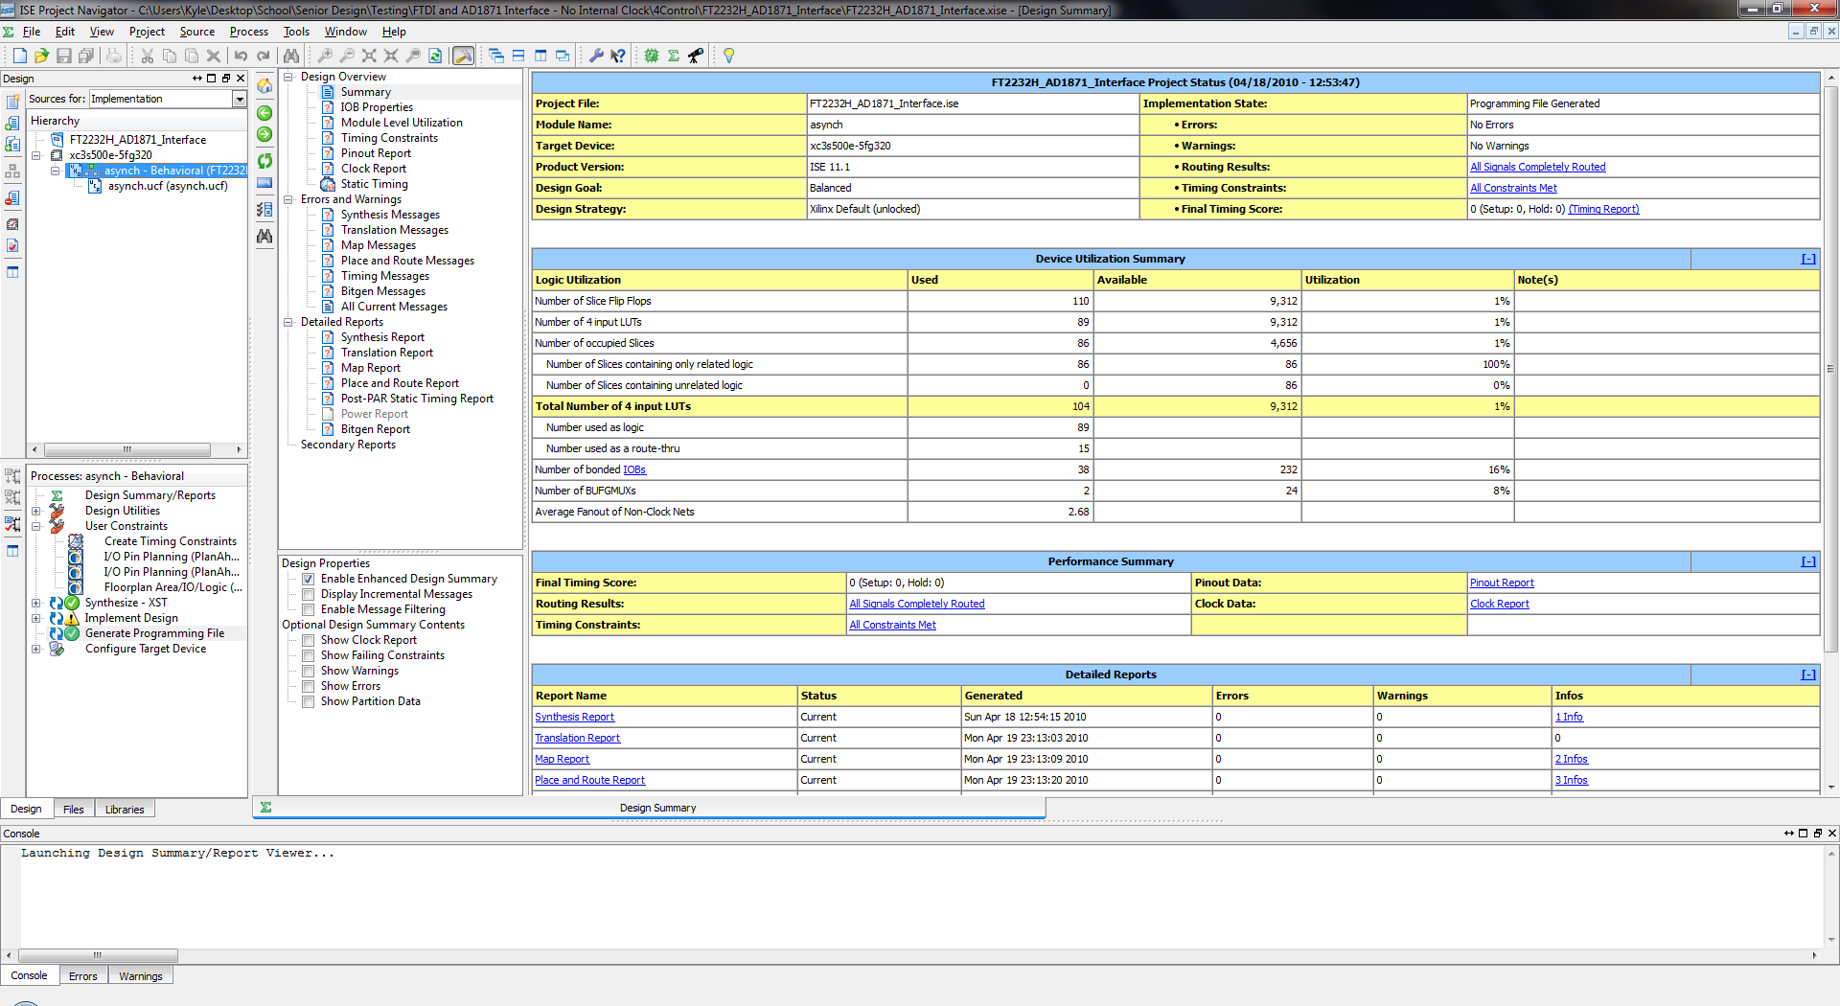

Figure 3: Design Hierarchy

1. Changes can now be made to the .vhdl file. After a change is made and the code is saved (Ctrl + s or 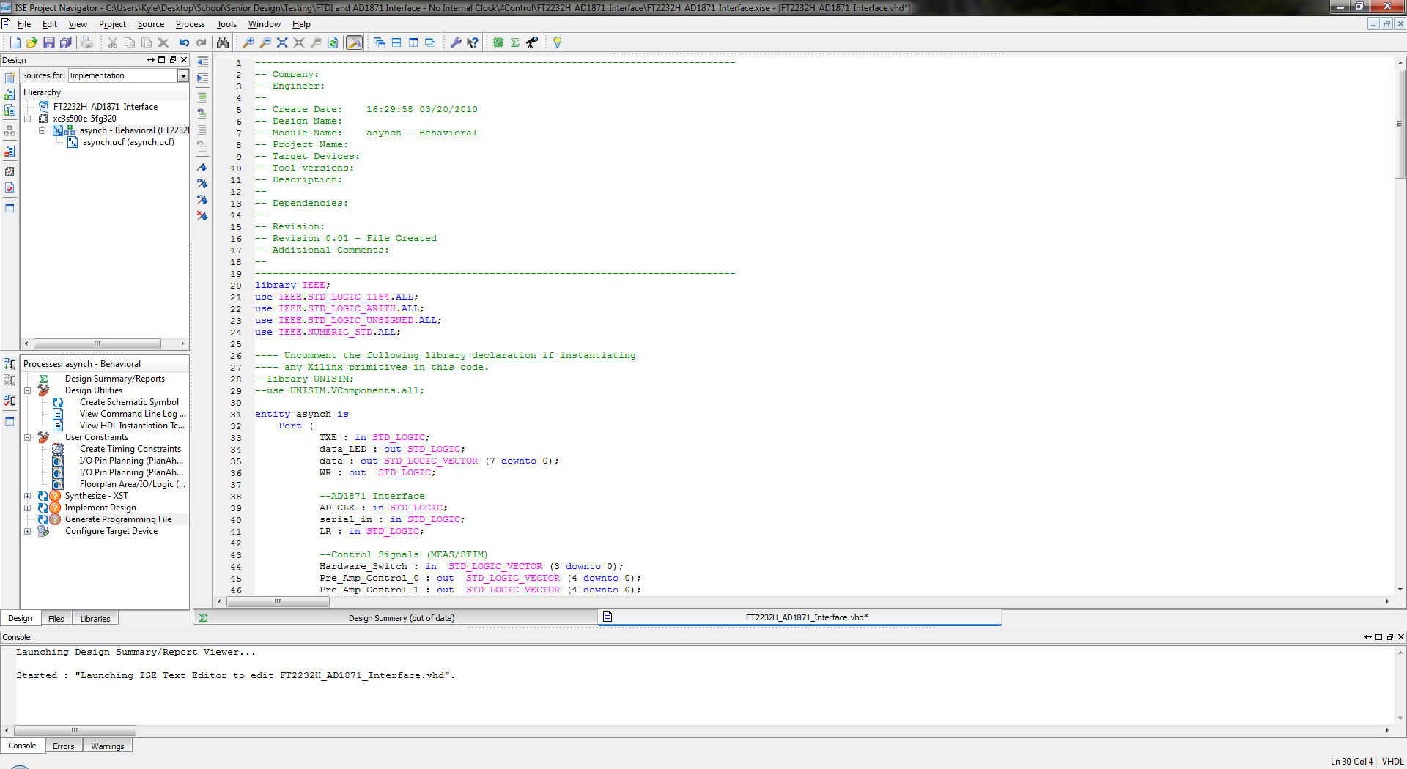) a question mark symbol () will display next to Synthesize – XST, Implement Design, and Generate Programming File. Note the Design tab should be selected as shown in Figure 4.



Figure 4: Processes Menu

1. To Synthesize the code double click on Synthesize – XST (Figure 4). This will check the syntax of the code and any errors or warnings will be displayed in the console (shown in Figure 5). The Errors tab and the Warnings tab allow the user to filter the console and show only Errors or Warnings.



Figure 5: Console

1. If the code synthesizes properly a programming file can now be generated by double clicking on Generate Programming File. This will generate a .bit file that can be used to program the FPGA. Once again the console (Figure 5) will show any Errors or Warnings that have occurred.

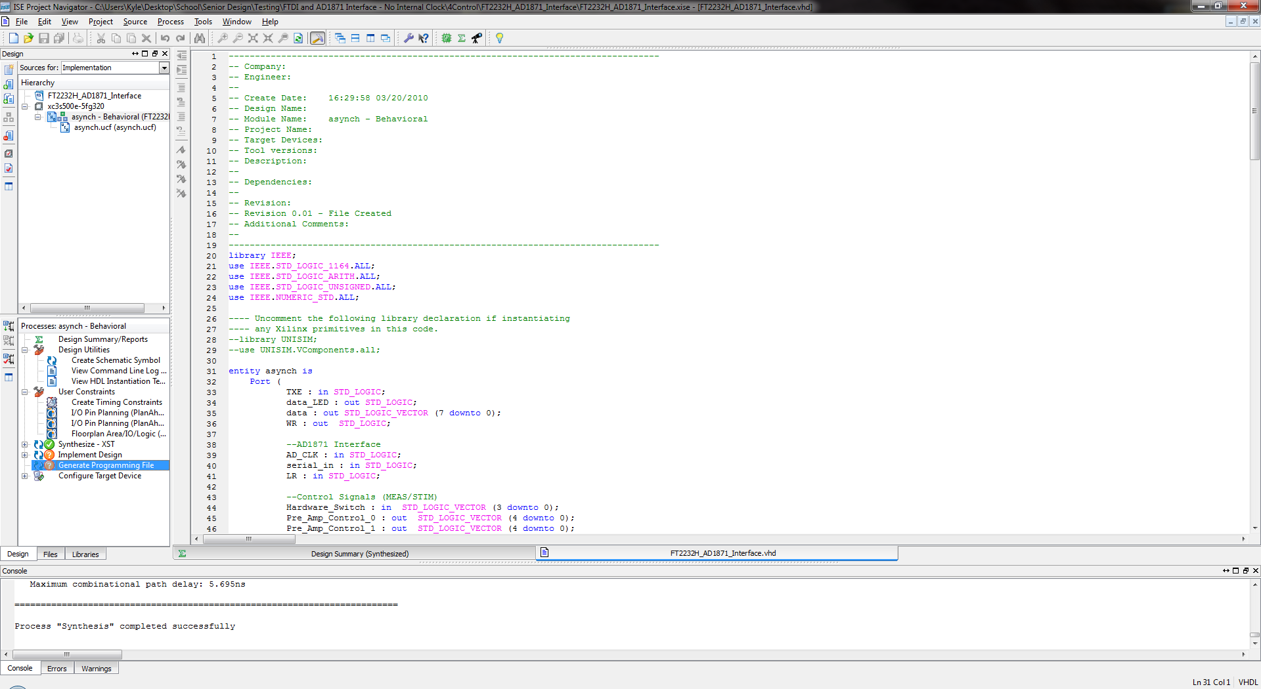

Figure 6: Generate Programming File

1. In order to program the FPGA with the .bit file Digilent’s Adept is used. Navigate to Start -> Programs -> Digilent -> Adept.
2. The Nexys2 should be connected via USB and powered on. In the upper right hand select the appropriate device to connect to as shown in Figure 7.

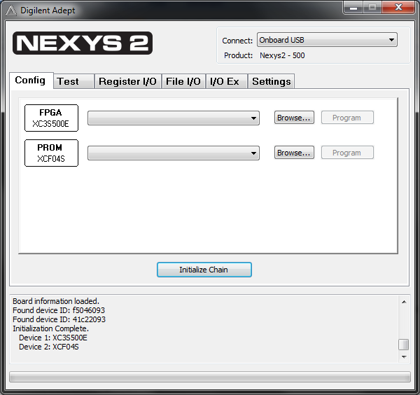

Figure 7: Adept with Connect circled

1. Hit Initialize Chain and then hit Browse. Select the desired .bit file and hit open on the window shown in Figure 8.

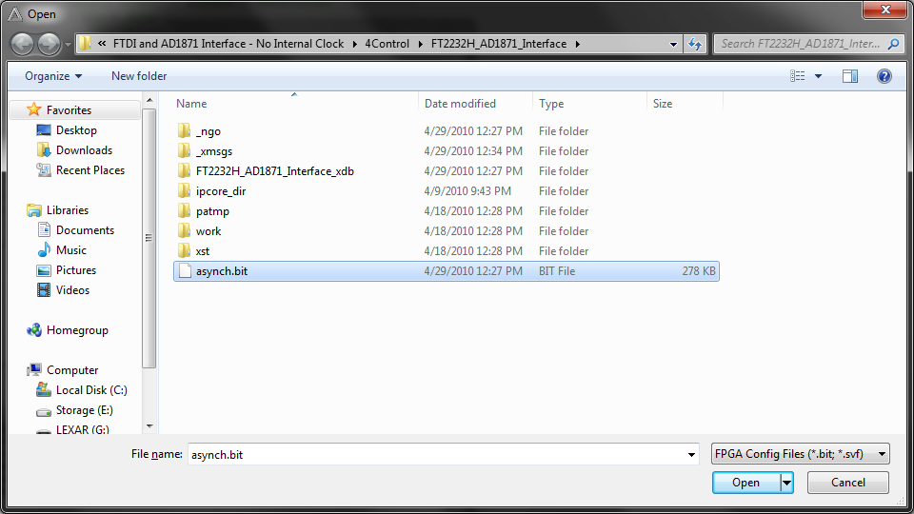

Figure 8: Browse Window

1. A warning window will come up (shown in Figure 9) that can be ignored. Hit yes.

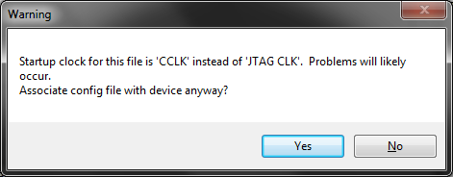

Figure 9: Warning Box

1. Hit program. This will cause the programming… to be displayed in the console and a green status bar to display as shown in Figure 10.

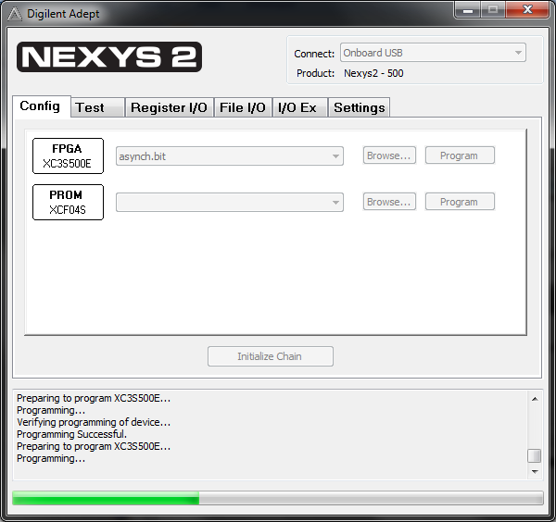

Figure 10: Programming

1. Once complete the console will display Programming Successful.

## 11.3 Microsoft Visual Studio® User Guide

**Opening and Modifying a Project:**

1. Open Visual Studio: Start -> Programs -> Microsoft Visual Studio 2008 -> Microsoft Visual Studio 2008

2. Select File -> Open -> Project/Solution… (shown in Figure 1).

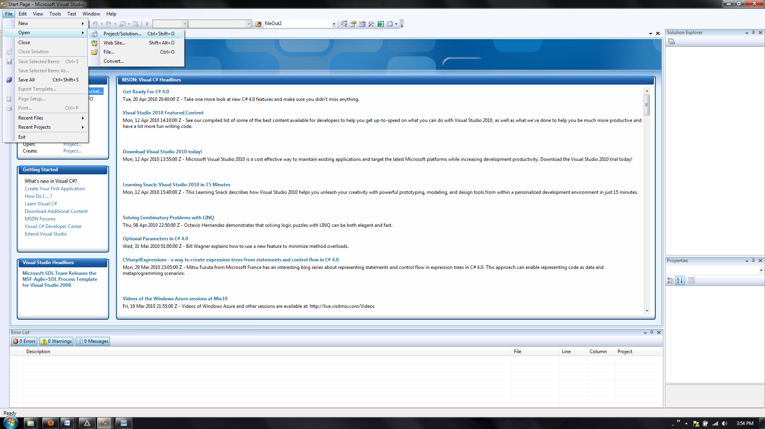

Figure 1: Open Project

3. Select the appropriate solution file (.sln) and hit Open as shown in Figure 2.

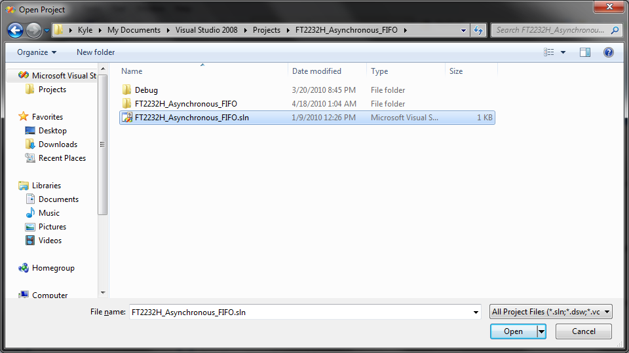

Figure 2: Opening Solution

4. The Solution Explorer (Figure 3) gives an overview of the files within the solution. Double click the source file that is to be modified.

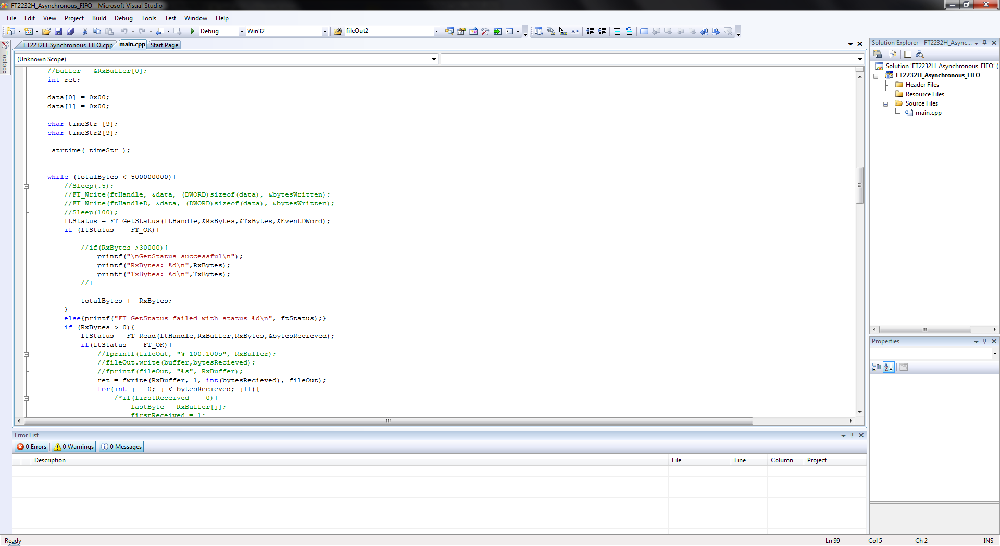

Figure 3: Solution Explorer

5. Changes can now be made to the source file. Once complete save the file and select Build -> Build Solution as shown in Figure 4.

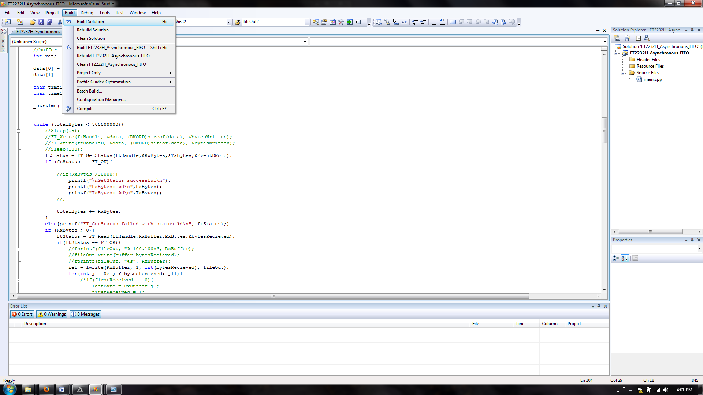

Figure 4: Build Solution

6. The console on the bottom of the program will show any errors or warnings that occur during the build. Once the build is successful the code can be run by selecting Debug -> Start Without Debugging.

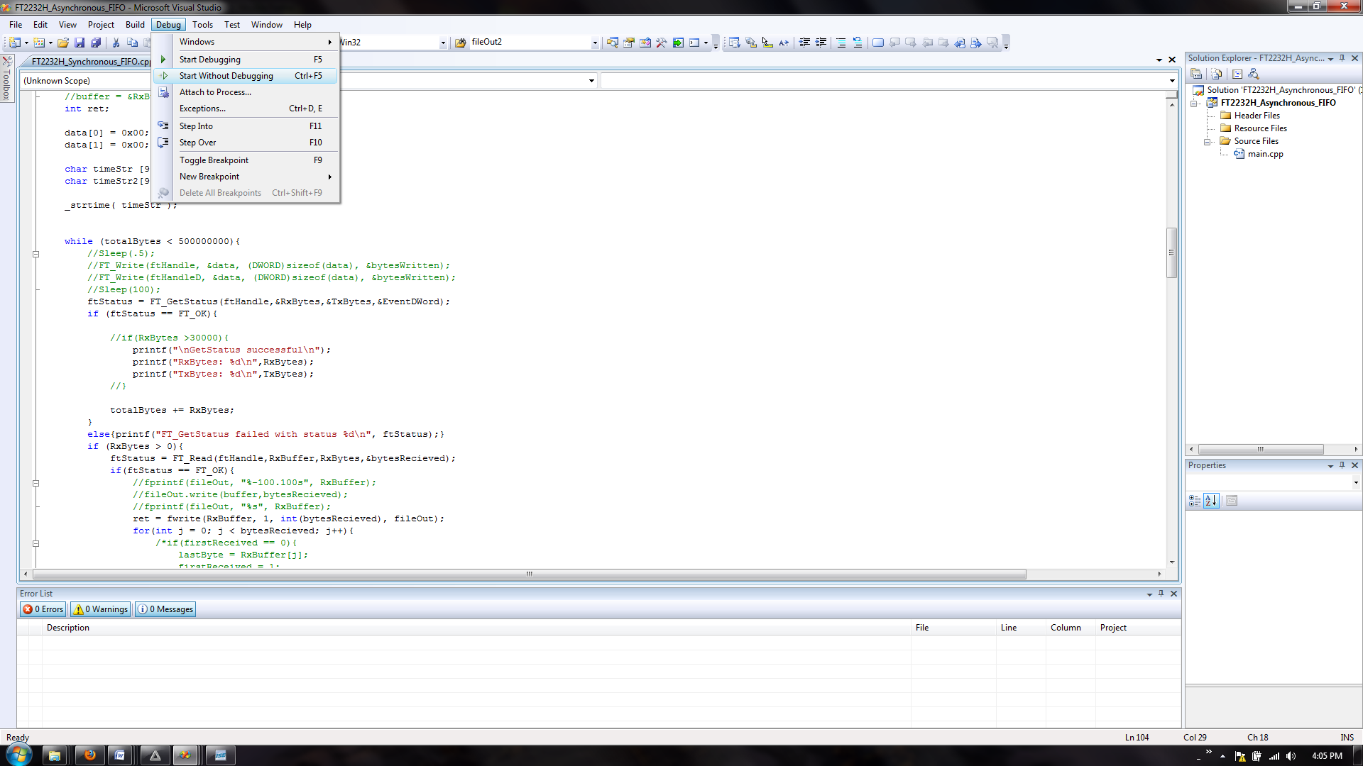

Figure 5: Start Without Debugging

## 11.4 Parts List

|  |  |  |  |  |  |  |  |  |  |  |  |  |  |  |  |  |
| --- | --- | --- | --- | --- | --- | --- | --- | --- | --- | --- | --- | --- | --- | --- | --- | --- |
| **Digital** | |  | | | |  | | |  | | | | | |  | |
| ***Part Description*** | | ***Part Number*** | | | | ***Quantity*** | | | ***Unit Price*** | | | | | | ***Amount*** | |
| 3.9V Zener Diode | | 1N4730AFSCT-ND | | | | 16 | | | $ 0.33 | | | | | | $ 5.34 | |
| IC MCU 128/16k Flash/SRAM 64LQFP | | MCF51JM128VLH-ND | | | | 1 | | | $ 6.90 | | | | | | $ 6.90 | |
| Kit Demo for JM MCU Family | | DEMOJM-ND | | | | 1 | | | $ 99.00 | | | | | | $ 99.00 | |
| Audio ADC | | AD1871YRSZ | | | | 3 | | | $ 12.79 | | | | | | $ 38.37 | |
| FTDI FT2232H | | FT2232H | | | | 1 | | | $ 27.00 | | | | | | $ 27.00 | |
| OSCILLATOR 12.2880MHZ PDIP | | SER1233-ND | | | | 1 | | | $ 5.15 | | | | | | $ 5.15 | |
| DIODE ZENER 3.9V | | 1N4730AFSCT-ND | | | | 6 | | | $ 0.51 | | | | | | $ 3.06 | |
| IC ISOLATOR DGTL 4CH 28SOIC | | ADUM1420BRWZ-ND | | | | 4 | | | $ 5.22 | | | | | | $ 20.88 | |
| IC TRANSCVR TRI-ST DL 24TSSOP | | 568-1586-5-ND | | | | 10 | | | $ 0.96 | | | | | | $ 9.60 | |
| Breakout Board | |  | | | | 1 | | | $ 10.00 | | | | | | $ 10.00 | |
|  | |  | | | |  | | |  | | | | | |  | |
|  | |  | | | | Total Invoice | | | | | | | | | $ 225.30 | |
|  | |  | | | | Shipping | | | |  | | | | | $ 26.81 | |
|  | |  | | | | Total Charged | | | | | | | | | $ 252.11 | |
| **Enclosure** | | | |  | |  | | |  | | | | | |  | | | |
| ***Part Description*** | | | | ***Part Number*** | | ***Quantity*** | | | ***Unit Price*** | | | | | | ***Amount*** | | | |
| BNC 50Ohm Connector | | | | A24520-ND | | 12 | | | $ 2.68 | | | | | | $ 32.16 | | | |
| USB Female To Male | | | | AE1474-ND | | 4 | | | $ 5.61 | | | | | | $ 22.44 | | | |
| Red Banana Jack | | | | J151-ND | | 12 | | | $ 0.53 | | | | | | $ 6.31 | | | |
| Black Banana Jack | | | | J152-ND | | 8 | | | $ 0.59 | | | | | | $ 4.72 | | | |
| White Banana Jack | | | | J150-ND | | 8 | | | $ 0.59 | | | | | | $ 4.72 | | | |
| 1/2" Aluminum Standoff | | | | 3487K-ND | | 30 | | | $ 0.37 | | | | | | $ 11.01 | | | |
| 2 Pos Shunt | | | | A31697-ND | | 10 | | | $ 0.13 | | | | | | $ 1.25 | | | |
| Chassis Alum 13 x 17 x 5 | | | | 377-1005-ND | | 1 | | | $ 66.20 | | | | | | $ 66.20 | | | |
| Chassis Bottom | | | | 377-1054-ND | | 1 | | | $ 15.80 | | | | | | $ 15.80 | | | |
| Adapter BNC 75 Ohm | | | | 501-1154-ND | | 4 | | | $ 3.93 | | | | | | $ 15.72 | | | |
| 4 Pos 3A Switch | | | | SW120-ND | | 1 | | | $ 1.23 | | | | | | $ 1.23 | | | |
| Mini Alligator Clips | | | | 314-1011-ND | | 4 | | | $ 0.24 | | | | | | $ 0.96 | | | |
| DB9 Female Sld Cup | | | | 209FE-ND | | 8 | | | $ 1.19 | | | | | | $ 9.52 | | | |
| DB9 Cables | | | | AE9869-ND | | 4 | | | $ 3.74 | | | | | | $ 14.96 | | | |
| CONN SCREW LOCK FEMALE 4-40 ZINC | | | | 5207953-2-ND | | 4 | | | $ 0.54 | | | | | | $ 2.16 | | | |
| HEX NUT 4-40 | | | | A35230-ND | | 10 | | | $ 0.07 | | | | | | $ 0.74 | | | |
| CONN HEADER .100" 40POS SGL GOLD | | | | SAM1098-40-ND | | 6 | | | $ 5.14 | | | | | | $ 30.84 | | | |
|  | | | |  | |  | | |  | | | | | |  | | | |
|  | | | |  | | Total Invoice | | | | | | | | | $ 240.74 | | | |
|  | | | |  | | Shipping | | | | | | |  | | $ 0.98 | | | |
|  | | | |  | | Total Charged | | | | | | | | | $ 241.72 | | | |
| **Analog** | | |  | | |  | | | |  | | | | |  | | |
| ***Part Description*** | | | ***Part Number*** | | | ***Quantity*** | | | | ***Unit Price*** | | | | | ***Amount*** | | |
| Instrumentation Amplifier | | | INA111BU-ND | | | 5 | | | | $ 16.94 | | | | | $ 84.70 | | |
| Quad Operational Amplifiers | | | LT1125CSW#PBF-ND | | | 5 | | | | $ 12.40 | | | | | $ 62.00 | | |
| IC Quad Switch | | | ADG202AKRZ-ND | | | 5 | | | | $ 3.26 | | | | | $ 16.30 | | |
| 887 Ohm 1/4W 1% 1206 SMD | | | 311-887FRCT-ND | | | 10 | | | | $ 0.08 | | | | | $ 0.82 | | |
| 1k Ohm 1/4W 1% 1206 SMD | | | 311-1.00KFRCT-ND | | | 10 | | | | $ 0.08 | | | | | $ 0.82 | | |
| 7.68k Ohm 1/4W 1% 1206 SMD | | | 311-7.68KFRCT-ND | | | 10 | | | | $ 0.08 | | | | | $ 0.82 | | |
| 13k Ohm 1/4W 1% 1206 SMD | | | 311-13.0KFRCT-ND | | | 40 | | | | $ 0.08 | | | | | $ 3.28 | | |
| 16.9k Ohm 1/4W 1% 1206 SMD | | | 311-16.9KFRCT-ND | | | 20 | | | | $ 0.08 | | | | | $ 1.64 | | |
| 19.6k Ohm 1/4W 1% 1206 SMD | | | 311-19.6KFRCT-ND | | | 10 | | | | $ 0.08 | | | | | $ 0.82 | | |
| 49.9k Ohm 1/4W 1% 1206 SMD | | | 311-49.9KFRCT-ND | | | 10 | | | | $ 0.08 | | | | | $ 0.82 | | |
| 76.8k Ohm 1/4W 1% 1206 SMD | | | 311-76.8KFRCT-ND | | | 10 | | | | $ 0.08 | | | | | $ 0.82 | | |
| 1100PF 50V 5% COG 0805 | | | 490-1623-1-ND | | | 30 | | | | $ 0.11 | | | | | $ 3.42 | | |
| .1uF 250V X7R 1206 Ceramic | | | 399-4674-1-ND | | | 40 | | | | $ 0.39 | | | | | $ 15.40 | | |
| .47uF 50V X7R 1206 Ceramic | | | 399=3498-1-ND | | | 10 | | | | $ 0.46 | | | | | $ 4.64 | | |
| 47uF 35V 20% SMD Tantalum | | | 495-2287-1-ND | | | 16 | | | | $ 1.91 | | | | | $ 30.48 | | |
| Dual Operational Amplifiers | | | LT1124CS8#PBF-ND | | | 5 | | | | $ 7.40 | | | | | $ 37.00 | | |
| SMA Female PCB Mount | | | CONSMA001-ND | | | 8 | | | | $ 3.69 | | | | | $ 29.52 | | |
| SMA Female R/A PCB Mount | | | CONSMA002-ND | | | 16 | | | | $ 3.69 | | | | | $ 59.04 | | |
| IC SRAM 128kbit 15ns 64TQFP | | | 800-1385-ND | | | 1 | | | | $ 40.88 | | | | | $ 40.88 | | |
| 50V 3A Rectifier | | | 1N5400DICT-ND | | | 6 | | | | $ 0.46 | | | | | $ 2.76 | | |
| 78.7k Ohm 1/4W 1% 1206 SMD | | | 311-78.7KFRCT-ND | | | 10 | | | | $ 0.08 | | | | | $ 0.82 | | |
| 80.6k Ohm 1/4W 1% 1206 SMD | | | 311-80.6KFRCT-ND | | | 10 | | | | $ 0.08 | | | | | $ 0.82 | | |
| IC OP-AMP LOW NOISE QUAD 16-SOIC | | | LT1125CSW#PBF-ND | | | 1 | | | | $ 12.40 | | | | | $ 12.40 | | |
| CAP TANTALUM 47UF 35V 20% SMD | | | 495-2287-1-ND | | | 2 | | | | $ 2.19 | | | | | $ 4.38 | | |
| RES 10.0K OHM 1/4W 1% 1206 SMD | | | 311-10.0KFRCT-ND | | | 10 | | | | $ 0.08 | | | | | $ 0.82 | | |
| RES 15.0K OHM 1/4W 1% 1206 SMD | | | 311-15.0KFRCT-ND | | | 20 | | | | $ 0.08 | | | | | $ 1.64 | | |
| CAP 50V .1UF AXIAL CERAMIC X7R | | | 1109PHCT-ND | | | 20 | | | | $ 0.09 | | | | | $ 1.72 | | |
|  | | |  | | |  | | | |  | | | | |  | | |
|  | | |  | | | Total Invoice | | | | | | | | | $ 418.58 | | |
|  | | |  | | | Shipping | | | | | |  | | | $ 13.60 | | |
|  | | |  | | | Total Charged | | | | | | | | | $ 432.18 | | |

1. Some product names in this document are trademarks of their respective owners, e.g. ColdFire® (Freescale Semiconductor, Inc.), Visual Studio® (Microsoft Corporation), PCB123® (Sunstone Circuits), and Spartan® (Xlinix, Inc.). Trademark owner and company names (e.g. Tektronix®) may also be trademarks.